 

**SMART WALKING STICK FOR BLIND USING ARDUINO**

**A PROJECT REPORT**

***Submitted by***

KARTHIKEYAN.S [211417104110] KEVIN PRINCE JAYARAJ D[211417104119]

***in partial fulfillment for the award of the degree***

***of***

BACHELOR OF ENGINEERING

**IN**

COMPUTER SCIENCE AND ENGINEERING

**PANIMALAR ENGINEERING COLLEGE, CHENNAI-600123.**

**ANNA UNIVERSITY: CHENNAI 600 025**

**APRIL 2021**

**ANNA UNIVERSITY: CHENNAI 600 025**

BONAFIDE CERTIFICATE

Certified that this project report “**SMART WALKING STICK FOR BLIND USING ARDUINO”** is the bonafide work of “**KARTHIKEYAN S[211417104110] KEVIN PRINCE JAYARAJ D[211417104119]”** who carried out the project work under my supervision.

### SIGNATURE SIGNATURE

**Dr. S. MURUGAVALLI, M.E., Ph.D., S.A.K. JAINULABUDEEN, M. Tech., PROFESSOR SUPERVISOR**

**HEAD OF THE DEPARTMENT ASSISTANT PROFESSOR**

DEPARTMENT OF CSE, DEPARTMENT OF CSE,

PANIMALAR ENGINEERING COLLEGE, PANIMALAR ENGINEERING COLLEGE,  
 NASARATHPETTAI, NASARATHPETTAI,

POONAMALLEE, POONAMALLEE,

CHENNAI-600 123. CHENNAI-600 123.

Certified that the above candidate(s) was/ were examined in the Anna University Project Viva-Voce Examination held on ...........................

### INTERNAL EXAMINER EXTERNAL EXAMINER

**ACKNOWLEDGEMENT**

Our sincere, humble and heartfelt thanks and praises to our honorable Founder and Chairman Late **Dr. JEPPIAAR, M.A., B.L., Ph.D.,** for his sincere Endeavor in educating us in his reputed institution.

We would like to express our deep gratitude to our respected Secretary and Correspondent **Dr. P. CHINNADURAI, M.A., Ph.D.** for his kind words and enthusiastic motivation, which inspired us a lot in completing this project.

We express our sincere thanks to our Directors **TMT. C. VIJAYARAJESWARI**, **Dr. C. SAKTHI KUMAR, M.E., Ph.D.,** and **TMT. SARANYA SREE SAKTHI**

**KUMAR, B.E.,** for providing us with the necessary facilities for completion of this project.

We also express our gratitude to our Principal **Dr. K. MANI, M.E., Ph.D.** for his timely concern and encouragement provided to us throughout the course.

We thank the Head of the CSE Department, **Dr. S. MURUGAVALLI, M.E., Ph.D.,**

for the support extended throughout the project.

We would like to thank our Supervisor **Mr. S.A.K. JAINULABUDEEN, M. Tech.,** and all the faculty members of the Department of CSE for their advice and suggestions for the successful completion of the project.

KARTHIKEYAN. S [211417104110] KEVIN PRINCE JAYARAJ. D [211417104119]

**ABSTRACT**

Obstacle detection is one of the major concerns for a fully or a partially blind person. This paper describes guide blind walking stick based on ultrasonic sensor with the use of Arduino Uno. According to World Health Organization (WHO), 30 million peoples are permanently blind and 285 billion peoples with vision impairment. In this paper discuss about smart guide blind stick, which is proficient of detecting any obstruction, detect corners and even allow the user to find the stick if anyhow missed by the user by pressing a remote switch. The device is designed with an objective to sort out common issues faced by the blind people while using conventional sticks. With the electronics embed within the stick, it became a smart stick. Presented here is a smart guide blind stick using Arduino. The stick uses Ultrasonic sensors for obstacle detection. The main aim of this paper is to detect nearby obstacle and notify the user of the direction of that obstacle, thereby enabling the user to determine the corrective direction to head.

TABLE OF CONTENTS

|  |  |  |
| --- | --- | --- |
| **CHAPTER NO.** | **TITLE** | **PAGE NO.** |
|  | **ABSTRACT** | iii |
|  | **LIST OF TABLES** | Vi |
|  | **LIST OF FIGURES** | vii |
|  | **LIST OF ABBREVIATIONS** | Ix |
| **1.** | **INTRODUCTION** | 2 |
|  | 1.1 Objective of the project | 3 |
|  | 1.2 Scope of the project | 3 |
| **2.** | **LITERATURE SURVEY** | 5 |
| **3.** | **SYSTEM ARCHITECTURE** | 9 |
| **4.** | **SYSTEM DESIGN** | 12 |
|  | 4.1 Propose System | 12 |
|  | 4.2 Hardware Requirement | 15 |
|  | 4.2.1 Arduiro Microcontroller | 15 |
|  | 4.3 Software Environment | 49 |
|  | 4.3.1 Arduiro Software (IDE) | 49 |
|  | 4.4 Embedded C | 55 |
| **5.** | **SYSTEM IMPLEMENTATION** | 65 |
|  | 5.1 Overview | 65 |
| **6.** | **SYSTEM TESTING** | 68 |
| **7.** | **CONCLUSION** | 70 |
|  | **APPENDICES** | 72 |
|  | A.1 Coding | 75 |
|  | A.2 Sample Screens | 77 |
|  | **REFERENCES** | 79 |

**LIST OF TABLES**

|  |  |  |
| --- | --- | --- |
| **TABLE NO.** | **TITLE** | **PAGE NO.** |
| **1.1** | Existing System and Proposed System | 2 |
| **4.1** | General Characteristics Of Some Active Sensors | 14 |
| **4.2** | Technical Specifications | 18 |
| **4.3** | Arduino Mega 2560 Pin Mapping Table | 20 |
| **4.4** | Ultrasonic Sensor Pin Configuration | 30 |
| **4.5** | Fire Sensor Pin Configuration | 35 |
| **4.6** | GSM Pin Specification | 44 |

LIST OF FIGUERS

|  |  |  |
| --- | --- | --- |
| **CHAPTER NO.** | **TITLE** | **PAGE NO.** |
| **3.1** | Block diagram for working of the project | 10 |
| **4.1** | Structural diagram of the project | 12 |
| **4.2** | Small and large obstacles detection | 13 |
| **4.3** | The “Arduino Mega 2560” | 17 |
| **4.4** | Arduino Mega 2560 PIN diagram | 19 |
| **4.5** | Working of Arduino IDE | 27 |
| **4.6** | Ultrasonic Sensor | 29 |
| **4.7** | US Sensor Working | 31 |
| **4.8** | Ultrasonic Distance Sensor Circuit | 32 |
| **4.9** | Fire Sensor | 34 |
| **4.10** | Fire Sensor circuit diagram | 36 |
| **4.11** | Vibration Sensor | 37 |
| **4.12** | GSM Module | 42 |
| **4.13** | IR Sensor | 45 |
| **4.14** | IR Sensor working module | 46 |
| **4.15** | Schematics IR Transmitter | 46 |
| **4.16** | IR receiver circuit | 47 |
| **4.17** | LDR sensor | 48 |
| **4.18** | Circuit diagram of LDR | 49 |
| **4.19** | Classification of tools in Arduino IDE | 50 |
| **4.20** | Libraries of Arduino IDE | 52 |
| **4.21** | Serial monitor | 54 |
| **4.22** | The Embedded C code block diagram to glow a bulb | 55 |
| **4.23** | Embedded C programming language | 56 |
| **4.24** | RTOS working module | 58 |
| **4.25** | Basic Structure of Embedded System | 59 |
| **4.26** | Flow chart for development of the system | 60 |

**LIST OF ABBREVIATIONS**

**TOF**-Time of flight

**SRAM-**Static Random-Access memory

**EEPROM-**Electronical Erasable Programmable Read Only Memory

**PWM-**Pulse Width Modulation

**AREF-**Analogue Reference

**DTR-**Digi tone Receiver technology

**MIDI-**Musical Instrument Digital Interface

**IC-** Integrated Circuit

**GSM-**Global System for Mobile

**SS-**Switching system

**BSS-**Business Support system

**OSS-**Operation and supporting system

**MXE-** message center

**MSN-** mobile service node

**MSC-** mobile services switching center

**DTMF-** dual-tone multifrequency

**CHAPTER 1 INTRODUCTION**

1. INTRODUCTION

According to the World Health Organization (WHO) statistics, around 30 billion people are blind on the earth. This project proposes to design and develop a portable unit (stick) for them for easy usage and navigation in public places. The blind stick is integrated with ultrasonic sensor along with light and water sensing. Our proposed project first uses ultrasonic sensors to detect obstacles ahead using ultrasonic waves. On sensing obstacles, the sensor passes this data to the microcontroller. The microcontroller then processes this data and calculates if the obstacle is close enough. If the obstacle is close the microcontroller sends a signal to sound a buzzer. It also detects and sounds a different buzzer if it detects water and alerts the blind. One more feature is that it allows the blind to detect if there is light or darkness in the room. A wireless RF based remote is used for this purpose. Pressing the remote button sounds a buzzer on the stick which helps the blind person to find their stick. Thus, this system allows person for obstacle detection as well as finding stick if misplaced by visually disabled person.

The difference of the existing system and proposed system is given below:

**TABLE 1.1 EXISTING SYSTEM AND PROPOSED SYSTEM:**

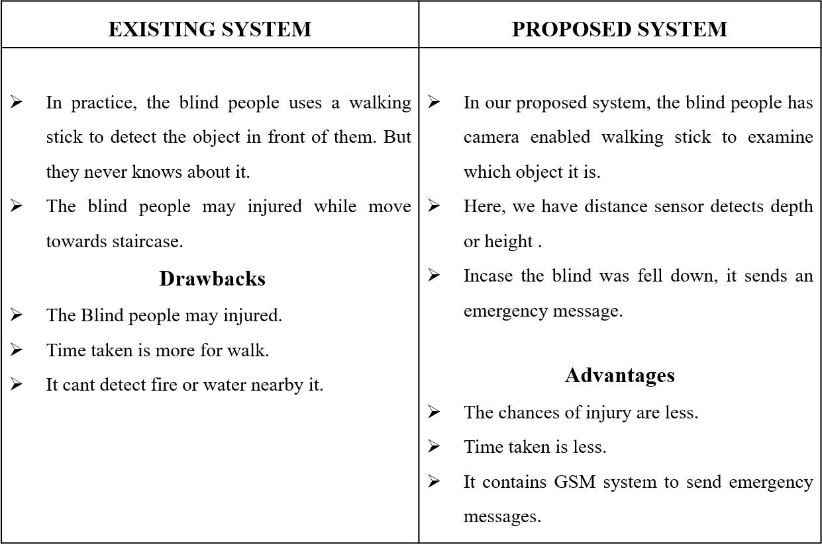

* 1. Objective of This Project:

The main objective is to help visually challenged people to navigate with ease using advance technology. In this technology-controlled world, where people strive to live independently. This project proposes an ultrasonic stick for blind people to help them gain personal independence Since this is economical and not bulky, one can make use of it easily

* 1. Scope of The Project:

The system can be supplemented with actual GPS MODULE used in cars and we can provide a vibrator for the partially deaf person. It can be further enhanced by using VLSI technology to design the PCB unit using Arduino. This makes the system furthermore compact. A wall following function can also be added so that the user can walk straight along a corridor in an indoor environment.

**CHAPTER 2 LITERATURE SURVEY**

1. LITERATURE SURVEY

A literature Survey is an objective, critical summary of published research literature relevant to a topic under consideration for research. Its purpose is to create familiarity with current thinking and research on a particular topic and may justify future research into a previously overlooked or understudied area. It is the most important part of the report as it gives a direction in the area of research. It helps to set a goal for the analysis thus giving out problem statement. A literature review in respect of the project, the researches made by various analysts – their methodology (which is basically their abstract) and the conclusions they have arrived at. It also gives an account of how this research has influenced the thesis.

**TITLE**: Smart Stick for the Blind a complete solution to reach the destination. [1]

**DESCRIPTION**: This system uses IR sensor, Ultrasound sensor and water sensor to detect the obstacle. However, this system just gives an alert if any one of the sensors is triggered, it uses a buzzer to alert the blind person. This system does not use any location identifier or location indicator.

**TITLE**: Pothole detection for visually impaired [2]

**DESCRIPTION**: which uses a camera that captures image 15 frame per second and based on the concept of image processing the pothole is detected. Problem with this system is use of camera makes it expensive, and also a lot of images captured per second increases overhead and storage requirement.

**TITLE**: Smart Walking Stick for Blind [3]

**DESCRIPTION**: describes about a Stick which use Raspberry Pi [10] and an ultrasonic sensor to detect objects and intruder, the system also has a camera embedded with it, and based on the images captured the objects are detected. The objects are analyzed based on the set of image datasets that are already stored. This system, however, becomes costly due to the use of high-end camera and also because of storage constraints as large volume of datasets are needed to be stored.

This system sometimes might also be inaccurate because the obstacles are detected based on dataset (large set of images) as different objects vary in their shape and size.

**TITLE**: Smart Belt for Blind [4]

**DESCRIPTION:** It uses a belt embedded with ultrasound sensor which detects the

obstacle. The belt also has a buzzer which vibrates when obstacle is detected. The entire system is developed in such a way that the distance calculated is sent as an audio message for the blind person, where in which he hears the distance calculated using a speaker.

**TITLE**: A wearable ultrasonic obstacle sensor for visually impaired. [5] **DESCRIPTION**: This system uses a couple of ultrasound sensor on either side over the strap of the goggles. This project can detect the intruder in front of the blind person who is wearing the goggles. This system is not robust as the sensor embedded with the goggles makes it heavier and also it cannot detect complex objects such as water, vehicle etc.

**TITLE:** Sensor assisted stick for the blind people describes about a wearable equipment [6]

**DESCRIPTION:** consists of a light weight blind stick and the obstacle detection circuit is based on a sensor .It is mainly developed to help the blind person to move alone safely from one place to another and to avoid any obstacles that may be encountered which may be either fixed or mobile, and thus it may help to avoid accidents. The main component for the working of this system is the infrared sensor which is used to scan a predetermined area around the blind person by emitting-reflecting waves. The reflected signals are received from the objects are used as inputs to the ATMEGA microcontroller. The microcontroller is then used for determining the direction and distance of the objects around the blind person. The main objective of this is to provide an application for blind people to detect the obstacles in various directions, detecting pits and manholes on the ground to make free to walk.

**TITLE:** Obstacle Detection and location finding For Blind People.[7]

**DESCRIPTION:** the author describes a device which is used for guiding the person who is blind or partially sighted. The system provides the voice alert to avoid obstacles in front of the blind. It is based on the ultrasonic sensors. An emergency button is added to the system. A RFID is installed into the public building and it is integrated into public building and also into the blind person walking stick. The device is designed as a small and is used with the white cane. The main aim of this system is to develop a system that assist the blind and visually impaired without the help of another person. The system is based on GSM-GPS and hence it takes the advantage of the GSM network such as the popularity and the cost. The RFID technology is used in indoor to assist the blind people,

because in the indoor the GPS cannot be

used efficiently. The GSM is also used for sending the alert message to the authorized person. The RFID is used for location detection in indoor and GPS is used for the outdoor location detection.

**TITLE:** multitasking stick for indicating safe path to visually disable people [8]

**DESCRIPTION:** It describes a micro-controller based automated hardware that allows a blind to detect obstacles in front of her or him .The system helps the blind person to navigate easily in a desired area .The hardware part consists of a micro-controller which was incorporated with an ultrasonic sensor, voice play back module and an additional equipment .The ultrasonic waves are used to detect the obstacles. The temperature sensors are provided to detect the fire or high temperature area. The presence of water is detected using the current sensing principle. The acknowledgement from the sensing obstacle is received through the voice play back module. The system can be provided a RF module which is used to find in the case of a misplaced stick, Because of these features the blind people can be able to move from one place to another independently.

**TITLE**: ultrasonic blind walking stick [9]

**DESCRIPTION:** an innovative stick which is designed for the visually disabled people for their easy navigation. Ultrasonic blind walking stick is an advanced blind stick that allows visually challenged people to navigate by using new technology. The blind stick can detect the light and water by integrated with ultrasonic sensor. In this system the ultrasonic sensors are used to detect obstacles by using ultrasonic waves. By sensing the obstacles, the sensor passes the received data to the microcontroller and the microcontroller processes this data and calculates if the obstacle is close enough to the person. If the obstacle is not close to the microcontroller the circuit does not do anything. If the obstacle is close enough to the microcontroller it sends a signal for sound a buzzer. It also detects water and provides different sounds and alerts the blind. The other feature is that it allows the blind to detect if there is light or darkness in the room.

**CHAPTER 3 SYSTEM ARCHITECTURE**

1. SYSTEM ARCHIETECTURE

System architecture is the process of defining the architecture, components, modules, interfaces, and data for a system to satisfy specified requirements. Systems architecture could be seen as the application of systems theory to product development. There is some overlap with the disciplines of system analysis, systems architecture and systems engineering.

* Ultrasonic sensors are used to sense the obstacle
* Obstacle is found within that range it gives beep speech through speaker
* Obstacles found in different directions beep and speech
* Top, Middle, Pit and Water
* The sound waves hits the obstacle and bounces back to detectors
* The signal is then send to microcontroller to operate a buzzer

BLOCK DIAGRAM:

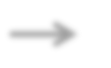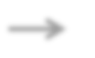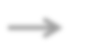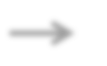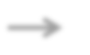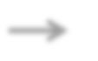

**ULTRASONIC**

**SENSOR**

**BUZZER**

**IR SENSOR**

**GSM**

**FIRE SENSOR**

**ARDUINO**

**MEGA**

**VIBRATION**

**SENSOR**

**LDR SENSOR**

**SOS BUTTON**

**POWER SUPPLY**

**Figure 3.1 Block diagram**

**CHAPTER 4 SYSTEM DESIGN**

1. **SYSTEM DESIGN**

4.1 PROPOSED SYSTEM

We have many reasons to design smart stick for blind; firstly, the blind to feel free, isn't surrounded by wires as in belt and its content. Secondly, is easy to use because it is familiar and affordable. Thirdly, to be able to detect obstacles that exist on the ground (this is not available in glasses), which he walks indoor and outdoor is faced by obstacles such as stairs, puddles and sidewalks.

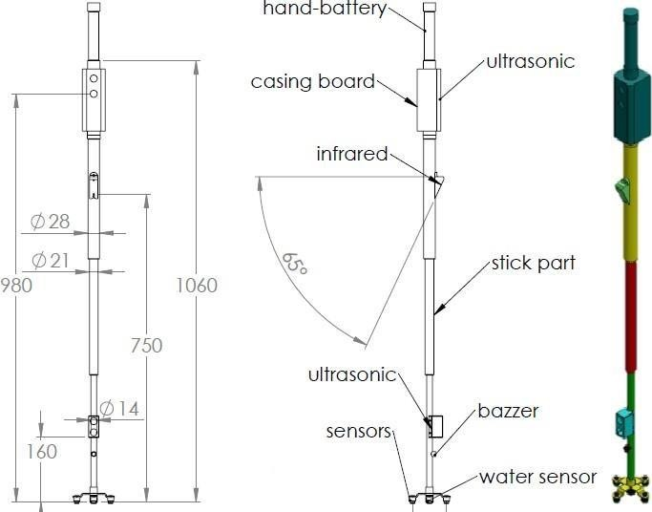The smart stick, as shown , is basically an embedded system integrating the following: pair of ultrasonic sensor to detect obstacles in front of the blind from ground level height to head level height in the range of 400 cm a head, infrared sensor to detect upward and downward stairs. Ultrasonic sensors and infrared sensor collect real time data and send it

Figure 4.1 Structural diagram of the project

**Sensors:**

The selection process of appropriate sensor depends on several factors such as, cost, atmospheric condition, kind of obstacle to be detected, detection range, and the desired precision of measurements collected information and its transmission frequency as shown in Table I.

We used a combination of 2 types of sensors infrared and ultrasonic for the following reasons:

1. Infrared sensor recognizes small obstacle but with less accuracy than laser sensors. However, using laser sensor is costly which contradicts our aim in obtaining affordable aiding devices. They perform almost the same within 2 meters.
2. Ultrasonic sensor works well for close obstacles unlike laser one, when an object is so close the laser sensor (less than 15 cm) can’t get an accurate reading. Moreover, it should be noted that radar sensors can easily detect near and far obstacles with equal perform once, but their medium accuracy doesn't allow them detecting small obstacles.

the atmospheric conditions. All obstacles reflect some part of the wave through. The amplitude of the wave reflected is relatively proportional to how much available surface there is on the obstacle, concerning coherent reflection. Also, surface area, shape and orientation, are major factors contributing to the strength of the reflected signal.

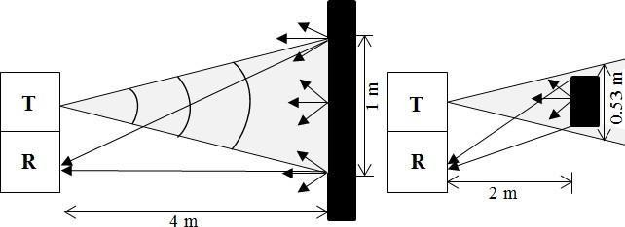

Figure 4.2 Small and large obstacles detection

**TABLE 4.1- GENERAL CHARACTERISTICS OF SOME ACTIVE SENSORS**

|  |  |  |  |  |
| --- | --- | --- | --- | --- |
|  | **Laser** | **Infrared** | **Radar** | **Ultrasonic** |
| Principle | Transmission And reception of  light wave | Transmission and reception of pulse pf IR light | Transmission and reception of microwave | Transmission and reception of acoustic  wave |
| Range | SLR:15cm  to120cm LLR: about 10-15m | From 20cm to 150cm | About 150m to 200 m | From 3cm to 10cm |
| Beam width | Narrow | Fairly thin | Depended on size of  antenna | wide |
| Atmospheric condition | affected | affected | affected | Not affected |
| Cost | Very high | low | high | low |

Infrared sensor chosen has a detection range distance that goes from 20 to 200 cm, a resolution of 0.5 cm, a frequency of 26.3 Hz and an analogical output that goes from 0 to 5 V.

Ultrasonic sensor used 40 kHz transmission signal. The 40 kHz frequency is produced by a transmission sensor of two- centimeter diameter; it can generate 2.4644 beams of narrowness. This is a reasonable size to be installed in the stick.

We use the infrared sensor to detect upward and downward stairs because the sensor spot is roughly 6 cm. This feature enables the user to identify precisely, any kind of stairs in front of him.

We use a pair of ultrasonic sensors. An upper one at a height 90 cm to detect upper obstacles and another sensor at a height 30 cm to detect low obstacles.

Detection using ultrasonic sensor is based on two factors:

* + Time of flight (TOF), the amount of delay between the emission of a sound and the arrival of an echo depending on the distance of an obstacle, which is directly proportional to the distance.
  + Beam size: Obstacle size is depending on amount of reflected wave. Obstacles whose dimensions are larger than the beam size, all of the sound waves will be reflected to receiver. If the obstacle size small as compared to the beam size, the part of the ultrasonic sound wave will be reflected to the receiver and the rest will be lost as shown in Fig. 4.

The speed at which sound travels depends on the medium it passes through. Broadly, the speed of sound is proportional to the square root of the ratio between the stiffness of the medium and its density. The speed of sound also changes with

4.2.HARDWARE REQUIREMENTS

**4.2.1.Arduino Microcontroller**

Arduino is an open-source electronics platform based on easy-to-use hardware and software. Arduino boards are able to read inputs - light on a sensor, a finger on a button, or a Twitter message - and turn it into an output - activating a motor, turning on an LED, publishing something online. You can tell your board what to do by sending a set of instructions to the microcontroller on the board.

Over the years Arduino has been the brain of thousands of projects, from everyday objects to complex scientific instruments. A worldwide community of makers - students, hobbyists, artists, programmers, and professionals - has gathered around this open-source platform, their contributions have added up to an incredible amount of accessible knowledge that can be of great help to novices and experts alike.

Arduino was born at the Ivrea Interaction Design Institute as an easy tool for fast prototyping, aimed at students without a background in electronics and programming. As soon as it reached a wider community, the Arduino board started changing to adapt to new needs and challenges, differentiating its offer from simple 8-bit boards to products for IoT applications, wearable, 3D printing, and embedded environments. All Arduino boards are completely open-source, empowering users to build them independently and eventually adapt them to their particular needs. The software, too, is open-source, and it is growing through the contributions of users world

Thanks to its simple and accessible user experience, Arduino has been used in thousands of different projects and applications. The Arduino software is easy-to-use for beginners, yet flexible enough for advanced users. It runs on Mac, Windows, and Linux. Teachers and students use it to build low cost scientific instruments, to prove chemistry and physics principles, or to get started with programming and robotics.

Designers and architects build interactive prototypes, musicians and artists use it for installations and to experiment with new musical instruments. Makers, of course, use it to build many of the projects exhibited at the Maker Faire, for example. Arduino is a key tool to learn new things. Anyone - children, hobbyists, artists, programmers - can start tinkering just following the step by step instructions of a kit or sharing ideas online with other members of the Arduino community.

There are many other microcontrollers and microcontroller platforms available for physical computing. Parallax Basic Stamp, Net media’s BX-24, Phidgets, MIT's Handy board, and many others offer similar functionality. All of these tools take the messy details of microcontroller programming and wrap it up in an easy-to-use package. Arduino also simplifies the process of working with microcontrollers, but it offers some advantage for teachers, students, and interested amateurs over other systems:

* + - * **Inexpensive** - Arduino boards are relatively inexpensive compared to other microcontroller platforms. The least expensive version of the Arduino module can be assembled by hand, and even the pre-assembled Arduino modules cost less than

$50.

* + - * **Cross-platform** - The Arduino Software (IDE) runs on Windows, Macintosh OSX, and Linux operating systems. Most microcontroller systems are limited to Windows.
      * **Simple, clear programming environment** - The Arduino Software (IDE) is easy- to-use for beginners, yet flexible enough for advanced users to take advantage of as well. For teachers, it's conveniently based on the Processing programming environment, so students learning to program in that environment will be familiar with how the Arduino IDE works.
      * **Open source and extensible software** - The Arduino software is published as open source tools, available for extension by experienced programmers. The language can be expanded through C++ libraries, and people wanting to understand the technical details can make the leap from Arduino to the AVR C programming language on which it's based. Similarly, you can add AVR-C code directly into your Arduino programs if you want to.

**Open source and extensible hardware** - The plans of the Arduino boards are published under a Creative Commons license, so experienced circuit designers can make their own version of the module, extending it and improving it. Even relatively inexperienced users can build the breadboard version of the module in order to understand how it works and save money.

ARDUINO MEGA 2560:

The **Arduino Mega 2560** is a microcontroller board based on the [ATmega2560](http://www.atmel.com/Images/Atmel-2549-8-bit-AVR-Microcontroller-ATmega640-1280-1281-2560-2561_datasheet.pdf). It has 54 digital input/output pins (of which 15 can be used as PWM outputs), 16 analog inputs, 4 UARTs (hardware serial ports), a 16 MHz crystal oscillator, a USB connection, a power jack, an ICSP header, and a reset button. It contains everything needed to support the microcontroller; simply connect it to a computer with a USB cable or power it with an AC -to-DC adapter or battery to get started. The Mega 2560 board is compatible with most shields designed for the Uno and the former boards Duemilanove or Diecimila.

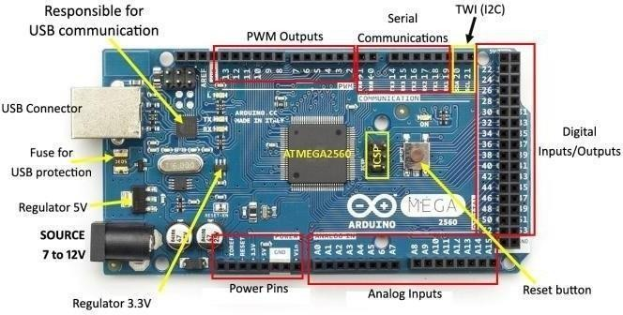

Figure 4.3 The "Arduino Mega 2560"

**Table 4.2 TECHNICAL SPECIFICATIONS**

|  |  |
| --- | --- |
| **Microcontroller** | [ATmega2560](http://www.atmel.com/Images/Atmel-2549-8-bit-AVR-Microcontroller-ATmega640-1280-1281-2560-2561_datasheet.pdf) |
| **Operating Voltage** | 5V |
| **Input Voltage (recommended)** | 7-12V |
| **Input Voltage (limit)** | 6-20V |
| **Digital I/O Pins** | 54 (of which 15 provide PWM output) |
| **Analog Input Pins** | 16 |
| **DC Current per I/O Pin** | 20 Ma |
| **DC Current for 3.3V Pin** | 50 Ma |
| **Flash Memory** | 256 KB of which 8 KB used by boot loader |
| **SRAM** | 8 KB |
| **EEPROM** | 4 KB |
| **Clock Speed** | 16 MHz |
| **LED_BUILTIN** | 13 |
| **Length** | 101.52 mm |
| **Width** | 53.3 mm |
| **Weight** | 37 g |

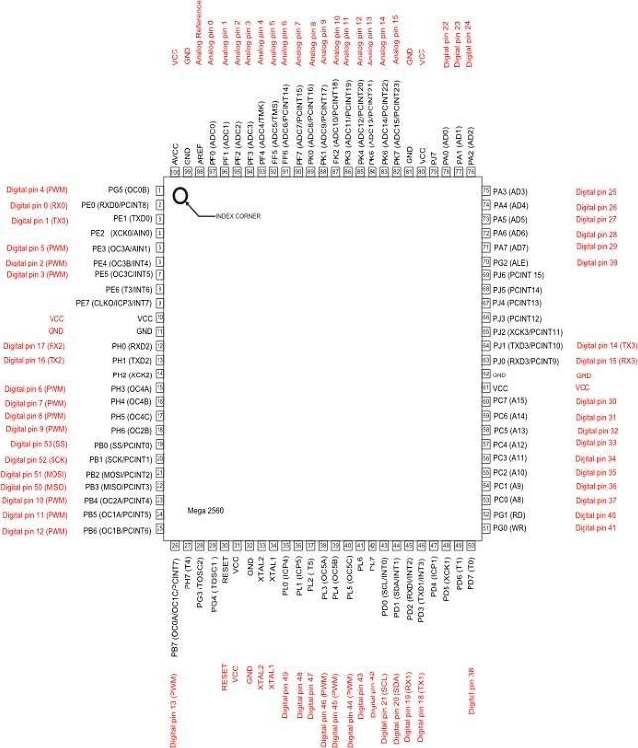

**Figure 4.4 PIN diagram Arduino Mega 2560**

**Table 4.3 - Arduino Mega 2560 PIN mapping table**

|  |  |  |
| --- | --- | --- |
| **Pin Number** | **Pin Name** | **Mapped Pin Name** |
| 1 | PG5 (OC0B) | Digital pin 4 (PWM) |
| 2 | PE0 (RXD0/PCINT8) | Digital pin 0 (RX0) |
| 3 | PE1 (TXD0) | Digital pin 1 (TX0) |
| 4 | PE2 (XCK0/AIN0) |  |
| 5 | PE3 (OC3A/AIN1) | Digital pin 5 (PWM) |
| 6 | PE4 (OC3B/INT4) | Digital pin 2 (PWM) |
| 7 | PE5 (OC3C/INT5) | Digital pin 3 (PWM) |
| 8 | PE6 (T3/INT6) |  |
| 9 | PE7 (CLKO/ICP3/INT7) |  |
| 10 | VCC | VCC |
| 11 | GND | GND |
| 12 | PH0 (RXD2) | Digital pin 17 (RX2) |
| 13 | PH1 (TXD2) | Digital pin 16 (TX2) |
| 14 | PH2 (XCK2) |  |
| 15 | PH3 (OC4A) | Digital pin 6 (PWM) |
| 16 | PH4 (OC4B) | Digital pin 7 (PWM) |
| 17 | PH5 (OC4C) | Digital pin 8 (PWM) |
| 18 | PH6 (OC2B) | Digital pin 9 (PWM) |
| 19 | PB0 (SS/PCINT0) | Digital pin 53 (SS) |
| 20 | PB1 (SCK/PCINT1) | Digital pin 52 (SCK) |
| 21 | PB2 (MOSI/PCINT2) | Digital pin 51 (MOSI) |
| 22 | PB3 (MISO/PCINT3) | Digital pin 50 (MISO) |
| 23 | PB4 (OC2A/PCINT4) | Digital pin 10 (PWM) |
| 24 | PB5 (OC1A/PCINT5) | Digital pin 11 (PWM) |
| 25 | PB6 (OC1B/PCINT6) | Digital pin 12 (PWM) |
| 26 | PB7 (OC0A/OC1C/PCINT7) | Digital pin 13 (PWM) |
| 27 | PH7 (T4) |  |
| 28 | PG3 (TOSC2) |  |
| 29 | PG4 (TOSC1) |  |
| 30 | RESET | RESET |
| 31 | VCC | VCC |
| 32 | GND | GND |
| 33 | XTAL2 | XTAL2 |
| 34 | XTAL1 | XTAL1 |
| 35 | PL0 (ICP4) | Digital pin 49 |
| 36 | PL1 (ICP5) | Digital pin 48 |
| 37 | PL2 (T5) | Digital pin 47 |
| 38 | PL3 (OC5A) | Digital pin 46 (PWM) |
| 39 | PL4 (OC5B) | Digital pin 45 (PWM) |
| 40 | PL5 (OC5C) | Digital pin 44 (PWM) |
| 41 | PL6 | Digital pin 43 |
| 42 | PL7 | Digital pin 42 |
| 43 | PD0 (SCL/INT0) | Digital pin 21 (SCL) |
| 44 | PD1 (SDA/INT1) | Digital pin 20 (SDA) |
| 45 | PD2 (RXDI/INT2) | Digital pin 19 (RX1) |
| 46 | PD3 (TXD1/INT3) | Digital pin 18 (TX1) |
| 47 | PD4 (ICP1) |  |
| 48 | PD5 (XCK1) |  |
| 49 | PD6 (T1) |  |
| 50 | PD7 (T0) | Digital pin 38 |

|  |  |  |
| --- | --- | --- |
| 51 | PG0 (WR) | Digital pin 41 |
| 52 | PG1 (RD) | Digital pin 40 |
| 53 | PC0 (A8) | Digital pin 37 |
| 54 | PC1 (A9) | Digital pin 36 |
| 55 | PC2 (A10) | Digital pin 35 |
| 56 | PC3 (A11) | Digital pin 34 |
| 57 | PC4 (A12) | Digital pin 33 |
| 58 | PC5 (A13) | Digital pin 32 |
| 59 | PC6 (A14) | Digital pin 31 |
| 60 | PC7 (A15) | Digital pin 30 |
| 61 | VCC | VCC |
| 62 | GND | GND |
| 63 | PJ0 (RXD3/PCINT9) | Digital pin 15 (RX3) |
| 64 | PJ1 (TXD3/PCINT10) | Digital pin 14 (TX3) |
| 65 | PJ2 (XCK3/PCINT11) |  |
| 66 | PJ3 (PCINT12) |  |
| 67 | PJ4 (PCINT13) |  |
| 68 | PJ5 (PCINT14) |  |
| 69 | PJ6 (PCINT 15) |  |
| 70 | PG2 (ALE) | Digital pin 39 |
| 71 | PA7 (AD7) | Digital pin 29 |
| 72 | PA6 (AD6) | Digital pin 28 |
| 73 | PA5 (AD5) | Digital pin 27 |
| 74 | PA4 (AD4) | Digital pin 26 |
| 75 | PA3 (AD3) | Digital pin 25 |
| 76 | PA2 (AD2) | Digital pin 24 |
| 77 | PA1 (AD1) | Digital pin 23 |

|  |  |  |
| --- | --- | --- |
| 78 | PA0 (AD0) | Digital pin 22 |
| 79 | PJ7 |  |
| 80 | VCC | VCC |
| 81 | GND | GND |
| 82 | PK7 (ADC15/PCINT23) | Analog pin 15 |
| 83 | PK6 (ADC14/PCINT22) | Analog pin 14 |
| 84 | PK5 (ADC13/PCINT21) | Analog pin 13 |
| 85 | PK4 (ADC12/PCINT20) | Analog pin 12 |
| 86 | PK3 (ADC11/PCINT19) | Analog pin 11 |
| 87 | PK2 (ADC10/PCINT18) | Analog pin 10 |
| 88 | PK1 (ADC9/PCINT17) | Analog pin 9 |
| 89 | PK0 (ADC8/PCINT16) | Analog pin 8 |
| 90 | PF7 (ADC7) | Analog pin 7 |
| 91 | PF6 (ADC6) | Analog pin 6 |
| 92 | PF5 (ADC5/TMS) | Analog pin 5 |
| 93 | PF4 (ADC4/TMK) | Analog pin 4 |
| 94 | PF3 (ADC3) | Analog pin 3 |
| 95 | PF2 (ADC2) | Analog pin 2 |
| 96 | PF1 (ADC1) | Analog pin 1 |
| 97 | PF0 (ADC0) | Analog pin 0 |
| 98 | AREF | Analog Reference |
| 99 | GND | GND |
| 100 | AVCC | VCC |

Each of the 54 digital pins on the Mega can be used as an input or output, using **pinMode()**, **digitalWrite()**, and **digitalRead()** functions. They operate at 5 volts. Each pin can provide or receive 20 mA as recommended operating condition and has an internal pull-up resistor (disconnected by default) of 20-50 k ohm. A maximum of 40mA is the value that must not be exceeded to avoid permanent damage to the microcontroller. In addition, some pins have specialized **Functions:**

* + - * **Serial**: 0 (RX) and 1 (TX); Serial 1: 19 (RX) and 18 (TX); Serial 2: 17 (RX) and 16 (TX); Serial 3: 15 (RX) and 14 (TX). Used to receive (RX) and transmit (TX) TTL serial data. Pins 0 and 1 are also connected to the corresponding pins of the ATmega16U2 USB-to-TTL Serial chip.
      * **External Interrupts**: 2 (interrupt 0), 3 (interrupt 1), 18 (interrupt 5), 19 (interrupt 4), 20 (interrupt 3), and 21 (interrupt 2). These pins c an be configured to trigger an interrupt on a low level, a rising or falling edge, or a change in level. See the attachInterrupt() function for details.
      * **PWM**: 2 to 13 and 44 to 46. Provide 8 -bit PWM output with the analogWrite() function.
      * **SPI**: 50 (MISO), 51 (MOSI), 52 (SCK), 53 (SS). These pins support SPI communication using the[SPI library](https://www.arduino.cc/en/Reference/SPI). The SPI pins are also broken out on the ICSP header, which is physically compatible with the Arduino/Genuino Uno and the old Duemilanove and Diecimila Arduino boards.
      * **LED**: 13. There is a built-in LED connected to digital pin 13. When the pin is HIGH value, the LED is on, when the pin is LOW, it's off.
      * **TWI**: 20 (SDA) and 21 (SCL). Support TWI communication using the Wire library. Note that these pins are not in the same location as the TWI pins on the old Duemilanove or Diecimila Arduino boards.

See also the mapping Arduino Mega 2560 PIN diagram.

The Mega 2560 has 16 analog inputs, each of which provide 10 bits of resolution (i.e. 1024 different values). By default they measure from ground to 5 volts, though is it possible to change the upper end of their range using the AREF pin and analogReference() function. There are a couple of other pins on the board:

* + - * **AREF**. Reference voltage for the analog inputs. Used with analogReference().
      * **Reset**. Bring this line LOW to reset the microcontroller. Typically used to add a reset button to shields which block the one on the board.

COMMUNICATION:

The Mega 2560 board has a number of facilities for communicating with a computer, another board, or other microcontrollers. The ATmega2560 provides four hardware UARTs for TTL (5V) serial communication. An ATmega16U2 (ATmega 8U2 on the revision 1 and revision 2 boards) on the board channels one of these over USB and provides a virtual com port to software on the computer (Windows machines will need a .inf file, but OSX and Linux machines will recognize the board as a COM port automatically. The Arduino Software (IDE) includes a serial monitor which allows simple textual data to be sent to and from the board. The RX and TX LEDs on the board will flash when data is being transmitted via the ATmega8U2/ATmega16U2 chip and USB connection to the computer (but not for serial communication on pins 0 a nd 1).

A SoftwareSerial library allows for serial communication on any of the Mega 2560's digital pins.

The Mega 2560 also supports TWI and SPI communication. The Arduino Software (IDE) includes a Wire library to simplify use of the TWI bus; see the documentation for details. For SPI communication, use the SPI library.

PHYSICAL CHARACTERISTICS AND SHIELD COMPATIBILITY:

The maximum length and width of the Mega 2560 PCB are 4 and 2.1 inches respectively, with the USB connector and power jack extending beyond the former dimension. Three screw holes allow the board to be attached to a surface or case. Note that the distance between digital pins 7 and 8 is 160 mil (0.16"), not an even multiple of the 100mil spacing of the other pins.

The Mega 2560 is designed to be compatible with most shields designed for the Uno and the older Diecimila or Duemilanove Arduino boards. Digital pins 0 to 13 (and the adjacent AREF and GND pins), analog inputs 0 to 5, the power header, and ICSP header are all in equivalent locations. Furthermore, the main UART (serial port) is located on the same pins (0 and 1), as are external interrupts 0 and 1 (pins 2 and 3 respectively). SPI is available through the ICSP header on both the Mega 2560 and Duemilanove / Diecimila boards. Please note that I2C is not located on the same pins on the Mega 2560 board (20 and 21) as the Duemilanove/ Diecimila boards (analog inputs 4 and 5).

REVISIONS:

The Mega 2560 does not use the FTDI USB-to-serial driver chip used in past designs. Instead, it features the ATmega16U2 (ATmega8U2 in the revision 1 and revision 2 Arduino boards) programmed as a USB -to-serial converter. Revision 2 of the Mega 2560 board has a resistor pulling the 8U2 HWB line to ground, making it easier to put into DFU mode. Revision 3 of the Arduino board and the current Genuino Mega 2560 have the following improved features:

* + - * **1.0 pinout**: SDA and SCL pins - near to the AREF pin - and two other new pins placed near to the RESET pin, the IOREF that allow the shields to adapt to the voltage provided from the board. In future, shields will be compatible both with the board that use the AVR, which operate with 5V and with the board that uses ATSAM3X8E, that operate with 3.3V. The second one is a not connected pin, that is reserved for future purposes.

APPLICATIONS:

* Arduboy, a handheld game console based on Arduino.
* Arduinome, a MIDI controller device that mimics the Monome.
* Ardupilot, drone software and hardware.
* ArduSat, a cubesat based on Arduino.
* C-STEM Studio, a platform for hands-on integrated learning of computing, science, technology, engineering, and mathematics (C-STEM) with robotics.
* Data loggers for scientific research.
* OBDuino, a trip computer that uses the on-board diagnostics interface found in most modern cars

WORKING:

* . An Arduino is a Micro controller which runs based on the program uploaded to it.
* Open the code or sketch written in the Arduino software.
* Select the type of board. The ATmega2560 microcontroller is used in the Arduino Mega.
* Arduino mega has the control over the other sensors in the system.
* As per the program uploaded in the Micro controller it operates each and every sensor as like CPU,
* It performs as like it was programmed to perform.

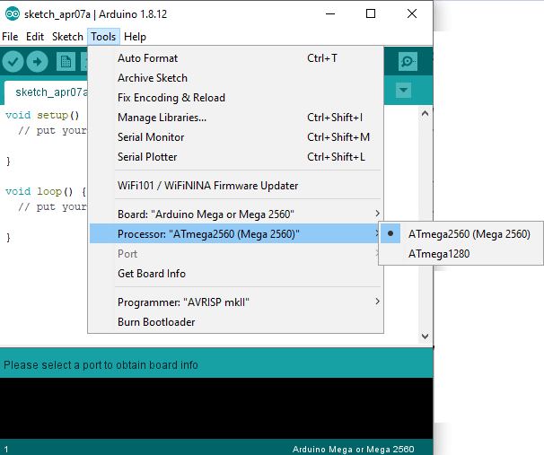

Figure 4.5 Working of Arduino IDE

* Now, **upload** and **run** the written code or sketch.

To upload and run, click on the button present on the top panel of the Arduino display, as shown below:

Arduino Mega

**1.2.ULTRASONIC SENSOR SOUND WAVES:**

Sound is a mechanical wave travelling through the mediums, which may be

a solid, or liquid or gas. Sound waves can travel through the mediums with specific velocity depends on the medium of propagation. The sound waves which are having high frequency reflect from boundaries and produces distinctive echo patterns.

Sound waves are having specific frequencies or number of oscillations per

second. Humans can detect sounds in a frequency range from about 20Hz to 20 KHz. However the frequency range normally employed in ultrasonic detection is 100 KHz to 50MHz. The velocity of ultrasound at a particular time and temperature is constant in a medium.

W = C/F (or) W = CT

Where W = Wavelength,

C = Velocity of sound in a medium, F = Frequency of wave,

T=Time Period.

The most common methods of ultrasonic examination utilize either longitudinal waves or shear waves. The longitudinal wave is a compression wave in which the particle motion is in the same direction of the propagation wave. The shear wave is a wave motion in which the particle motion is perpendicular to the direction of propagation. Ultrasonic detection introduces high frequency sound waves into a test object to obtain information about the object without altering or damaging it in any way. Two values are measured in ultrasonic detection.

The amount of time, taking for the sound to travel through the medium and amplitude of the received signal. Based on velocity and time thickness can be calculated.

Thickness of material = Material sound velocity X Time of Fight TRANSDUCERS FOR WAVE PROPAGATION AND PARTICLE DETECTION:

For sending sound waves and receiving echo, ultrasonic sensors, normally called transceivers or transducers will be used. They work on a principle similar to radar that will convert electrical energy into mechanical energy in the form of sound, and vice versa.

The commonly used transducers are contact transducers, angle beam transducers, delay line transducers, immersion transducers, and dual element transducers. Contact transducers are typically used for locating voids and cracks to the outside surface of a part as well as measuring thickness. Angle beam transducers use the principle of reflection and mode conversion to produce refracted shear or longitudinal waves in the test material.

Delay line transducers are single element longitudinal wave transducers used in conjunction with a replaceable delay line. One of the reasons for choosing delay line transducer is that near surface resolution can be improved. The delay allows the element to stop vibrating before a return signal from the reflector can be received.

The major advantages offered by immersion transducers over contact transducers are Uniform coupling reduces sensitivity variations, Reduction in scan time, and increases sensitivity to small reflectors.

ULTRASONIC SENSOR:

Ultrasonic detection is most commonly used in industrial applications to detect hidden tracks, discontinuities in metals, composites, plastics, ceramics, and for water level detection. For this purpose, the laws of physics which are indicating the propagation of sound waves through solid materials have been used since ultrasonic sensors using sound instead of light for detection.

An ultrasonic sensor is an instrument that measures the distance to an object using ultrasonic sound waves.

An ultrasonic sensor uses a transducer to send and receive ultrasonic pulses that relay back information about an object’s proximity.

High-frequency sound waves reflect from boundaries to produce distinct echo patterns.

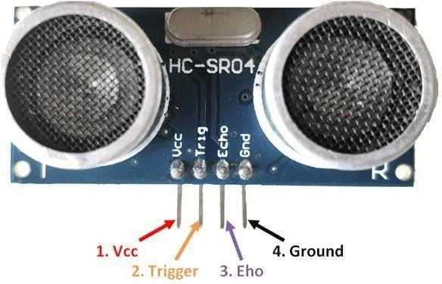

FIGURE 4.6 ULTASONIC SENSOR

When an electrical pulse of high voltage is applied to the ultrasonic transducer it vibrates across a specific spectrum of frequencies and generates a burst of sound waves. Whenever any obstacle comes ahead of the ultrasonic sensor the sound waves will reflect back in the form of echo and generates an electric pulse. It calculates the time taken between sending sound waves and receiving echo. The echo patterns will be compared with the patterns of sound waves to determine detected signal’s condition.

ULTRASONIC SENSOR PIN CONFIGURATION:

**TABLE 4.4 ULTRASONIC SENSOR PIN CONFIGURATION**

|  |  |  |
| --- | --- | --- |
| **PIN NUMBER** | **PIN NAME** | **DESCRIPTION** |
| 1 | Vcc | The Vcc pin powers the sensor, typically with +5V |
| 2 | Trigger | Trigger pin is an Input pin. This pin has to be kept high for 10us to initialize measurement by sending US wave. |
| 3 | Echo | Echo pin is an Output pin. This pin goes high for a period of time which will be equal to the time taken for the US wave to return back to the sensor. |
| 4 | Ground | This pin is connected to the Ground of the system. |

HC-SR04 SENSOR FEATURES:

* + Operating voltage: +5V.
  + Theoretical Measuring Distance: 2cm to 450cm
  + Practical Measuring Distance: 2cm to 80cm.
  + Accuracy: 3mm.
  + Measuring angle covered: <15°.
  + Operating Current: <15Ma.
  + Operating Frequency: 40Hz.

HC-SR04 ULTRASONIC SENSOR – WORKING:

As shown above the **HC-SR04 Ultrasonic (US) sensor** is a 4 pin module, whose pin names are Vcc, Trigger, Echo and Ground respectively. This sensor is a very popular sensor used in many applications where measuring distance or sensing objects are required. The module has two eyes like projects in the front which forms the Ultrasonic transmitter and Receiver. The sensor works with the simple high school formula that

Distance = Speed × Time

The Ultrasonic transmitter transmits an ultrasonic wave, this wave travels in air and when it gets objected by any material it gets reflected back toward the sensor this reflected wave is observed by the Ultrasonic receiver module as shown in the picture below.

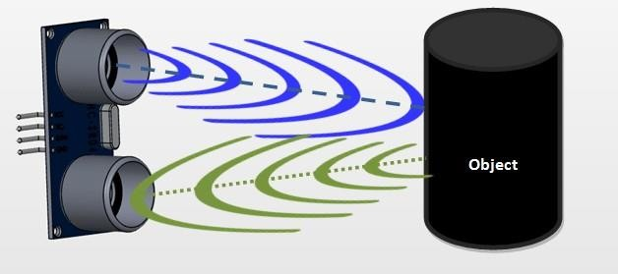

FIGURE 4.7 US SENSOR WOTKING

Now, to calculate the distance using the above formulae, we should know the Speed and time. Since we are using the Ultrasonic wave, we know the universal speed of US wave at room conditions which is 330m/s. The circuitry inbuilt on the module will calculate the time taken for the US wave to come back and turns on the echo pin high for that same particular amount of time, this way we can also know the time taken. Now simply calculate the distance using a microcontroller or microprocessor.

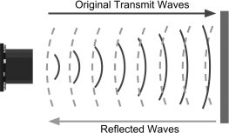

The working principle of this module is simple. It sends an ultrasonic pulse out at 40kHz which travels through the air and if there is an obstacle or object, it will bounce back to the sensor. By calculating the travel time and the speed of sound, the distance can be calculated.

Ultrasound is reliable in any lighting environment and can be used inside or outside. Ultrasonic sensors can handle collision avoidance for a robot, and being moved often, as long as it isn’t too fast.

Ultrasonics are so widely used, they can be reliably implemented in grain bin sensing applications, water level sensing, drone applications and sensing cars at your local drive-thru restaurant or bank.

Ultrasonic rangefinders are commonly used as devices to detect a

collision.

Ultrasonic sensor module comprises of one transmitter and one receiver.

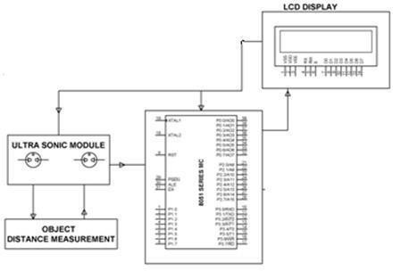The transmitter can deliver 40 KHz ultrasonic sound while the maximum receiver is designed to accept only 40 KHz sound waves. The receiver ultrasonic sensor that is kept next to the transmitter shall thus be able to receive reflected 40 KHz, once the module faces any obstacle in front. Thus, whenever any obstacles come ahead of the ultrasonic module it calculates the time taken from sending the signals to receiving them since time and distance are related for sound waves passing through air medium at 343.2m/sec. Upon receiving the signal MC program while executed displays the data i.e. the distance measured on an LCD interfaced to the microcontroller in cms.

4.8 Figure Ultrasonic Distance Sensor Circuit

Characteristically, robotics applications are very popular, but you’ll also find this product to be useful in security systems or as an infrared replacement if so desired.

HOW TO USE THE HC-SR04 ULTRASONIC SENSOR:

**HC-SR04 distance sensor** is commonly used with both microcontroller and microprocessor platforms like Arduino, ARM, PIC, Raspberry Pie etc. The following guide is universally since it has to be followed irrespective of the type of computational device used.

Power the Sensor using a regulated +5V through the Vcc ad Ground pins of the sensor. The current consumed by the sensor is less than 15mA and hence can be directly powered by the on board 5V pins (If available). The Trigger and the Echo pins are both I/O pins and hence they can be connected to I/O pins of the microcontroller. To start the measurement, the trigger pin has to be made high for 10uS and then turned off. This action will trigger an ultrasonic wave at frequency of 40Hz from the transmitter and the receiver will wait for the wave to return. Once the wave is returned after it gets reflected by any object the Echo pin goes high for a particular amount of time which will be equal to the time taken for the wave to return back to the sensor.

The amount of time during which the Echo pin stays high is measured by the MCU/MPU as it gives the information about the time taken for the wave to return back to the Sensor. Using this information, the distance is measured as explained in the above heading.

APPLICATIONS:

* + Used to avoid and detect obstacles with robots like biped robot, obstacle avoider robot, path finding robot etc.
  + Used to measure the distance within a wide range of 2cm to 400cm.
  + Can be used to map the objects surrounding the sensor by rotating it.
  + Depth of certain places like wells, pits etc. can be measured since the waves can penetrate through water.

HC-SR04 ULTRASONIC SENSOR – WORKING:

* + As shown above the HC-SR04 Ultrasonic (US) sensor is a 4 pin module, whose pin names are Vcc, Trigger, Echo and Ground respectively. This sensor is a very popular sensor used in many applications where measuring distance or sensing objects are required. The module has two eyes like projects in the front which forms the Ultrasonic transmitter and Receiver. The sensor works with the simple high school formula that

Distance = Speed × Time

* + The Ultrasonic transmitter transmits an ultrasonic wave, this wave travels in air and when it gets objected by any material it gets reflected back toward the sensor this reflected wave is observed by the Ultrasonic receiver module as shown in next slide.

1.3.FIRE SENSOR

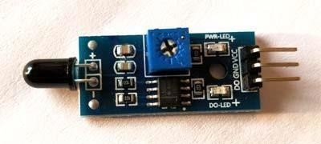A **flame detector** is a sensor designed to detect and respond to the presence of a flame or fire. Responses to a detected flame depend on the installation, but can include sounding an alarm, deactivating a fuel line (such as a propane or a natural gas line), and activating a fire suppression system.

Figure 4.9 Fire Sensor

There are different types of flame detection methods. Some of them are: Ultraviolet detector, near IR array detector, infrared (IR) detector, Infrared thermal cameras, UV/IR detector etc.

When fire burns it emits a small amount of Infra-red light, this light will be received by the Photodiode (IR receiver) on the sensor module. Then we use an Op-Amp to check for change in voltage across the IR Receiver, so that if a fire is detected the output pin (DO) will give 0V(LOW) and if the is no fire the output pin will be 5V(HIGH).

It is based on the YG1006 sensor which is a high speed and highly sensitive NPN silicon phototransistor. It can detect infrared light with a wavelength ranging from 700nm to 1000nm and its detection angle is about 60°. Flame sensor module consists of a photodiode (IR receiver), resistor, capacitor, potentiometer, and LM393 comparator in an integrated circuit. The sensitivity can be adjusted by varying the on-board potentiometer. Working voltage is between 3.3v and 5v DC, with a digital output. Logic high on the output indicates presence of flame or fire. Logic low on output indicates absence of flame or fire.

Flame sensor is the most sensitive to ordinary light that is why its reaction is generally used as flame alarm purposes. This module can detect flame

orwavelengthin760nmto1100nmrangeoflightsource.Smallplateoutputinterfacecanandsin gle-chip can be directly connected to the microcomputer IO port. The sensor and flame should keep a certain distance to avoid high temperature damage to the sensor. The shortest test distance is 80cm, if the flame is bigger test it with far distance. The detection angle is 60 degrees, so the flame spectrum is especially sensitive. The detection angle is 60 degrees, so the flame spectrum is especially sensitive.

Table 4.5 Fire sensor pin configuration

|  |  |
| --- | --- |
| **Pin** | **Description** |
| Vcc | 3.3 – 5V power supply |
| GND | Ground |
| Dout | Digital output |

**SPECIFICATIONS:**

* + - * On-boardLM393voltage comparator chip and infrared sensing probe.
      * Support5V/3.3V voltage input.
      * On-board signal output indication output effective signal is high level, and the same time the indicator light up, output signal can directly connect with microcontroller IO.
      * Signal detection sensitivity can be adjusted.
      * Reserved a line voltage compare circuit (P3 is leaded out).
      * PCB size: 30(mm) x 15(mm).

WORKING:

The **flame sensor detects the presence of fire** or flame based on the Infrared (IR) wavelength emitted by the flame. It gives logic 1 as output if flame is detected, otherwise it gives logic 0 as output. Arduino Uno checks the logic level on the output pin of the sensor and performs further tasks such as activating the buzzer and LED, sending an alert message.

FIRE SENSOR CIRCUIT DIAGRAM:

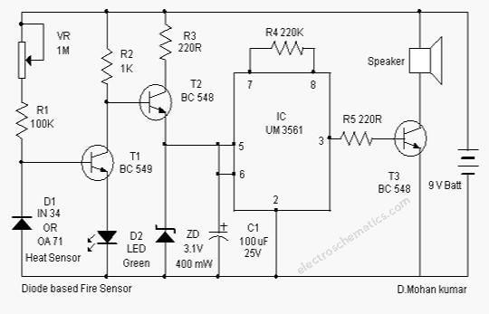

**Figure 4.10 Fire sensor circuit diagram**

This fire sensor circuit exploits the temperature sensing property of an ordinary signal diode IN 34 to detect heat from fire. At the moment it senses heat, a loud alarm simulating that of Fire brigade will be produced. The circuit is too sensitive and can detect a rise in temperature of 10 degree or more in its vicinity. Ordinary signal diodes like IN 34 and OA 71 exhibits this property and the internal resistance of these devices will decrease when temperature rises.

**The fire sensor circuit is too sensitive and can detect a rise in temperature of 10 degree or more in its vicinity**. Ordinary signal diodes like IN 34 and OA 71 exhibits this property and the internal resistance of these devices will decrease when temperature rises. In the reverse biased mode, this effect will be more significant. Typically, the diode can generate around 600 milli volts at 5 degree centigrade. For each degree rise in temperature; the diode generates 2 mV output voltage. That is at 5 degree it is 10 mV and when the temperature rises to 50 degree, the diode will give 100 milli volts. This voltage is used to trigger the remaining circuit. Transistor T1 is a temperature- controlled switch and its base voltage depends on the voltage from the diode and from VR and R1. Normally T1 conducts (due to the voltage set by VR) and LED glows. This indicates normal temperature.

When T1 conducts, base pf T2 will be grounded and it remains off to inhibit the Alarm generator. IC UM 3561 is used in the circuit to give a Fire force siren. This ROM IC has an internal oscillator and can generate different tones based on its pin connections. Here pin 6 is shorted with the Vcc pin 5 to get a fire force siren. When the temperature near the diode increases above 50 degree, it conducts and ground the base of T1. This makes T1 off and T2 on. Alarm generator then gets current from the emitter of T2 which is regulated by ZD to 3.1 volt and buffered by C1. Resistor R4 (220K) determines the frequency of oscillation and the value 220K is a must for correct tone. To set the fire sensor circuit, keep a lighted candle near the diode and wait for 1 minute. Slowly adjust VR till the alarm sounds. Remove the heat. After one minute, alarm will turn off. VR can be used for further adjustments for particular temperature levels.

APPLICATIONS OF FLAME SENSORS:

* + - * Hydrogen stations
      * Combustion monitors for burners
      * Oil and gas pipelines
      * Automotive manufacturing facilities
      * Nuclear facilities
      * Aircraft hangars
      * Turbine enclosures.

1.4.VIBRATION SENSOR

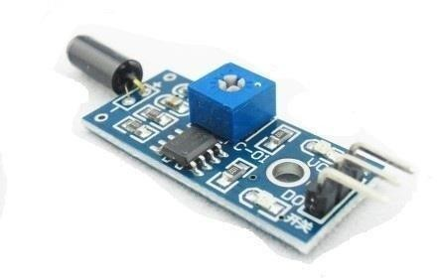

**Figure 4.11 Vibration sensor**

**GENERAL DESCRIPTION**

Vibration sensor usually at any angle switch is ON state, by the vibration or movement, the rollers of the conduction current in the switch will produce a movement or vibration, causing the current through the disconnect or the rise of the resistance and trigger circuit. The characteristics of this switch is usually general in the conduction state briefly disconnected resistant to vibration, so it's high sensitivity settings by IC, customers according to their sensitivity requirements for adjustments. Because it briefly the buzz film used in the conventional alarm device, the complex structure of the magnet plus the spring, and thus on the electric car alarm in recent years extensive application.

FEATURES

* Input voltage: 5v
* Output voltage: 3.5-5v
* Output: digital
* Life expectancy: 5, 00,000 times.
* Suitable for small current control circuit of trigger.
* Response time: 2ms

APPLICATIONS

* Anti-theft alarm.
* Smart Home systems.
* Automotive devices.
* Home electrical devices.

WORKING

This sensor module produce logic states depends on vibration and external force applied on it. When there is no vibration this module gives logic LOW output. When it feels vibration then output of this module goes to logic HIGH. The working bias of this circuit is between 3.3V to 5V DC.

The vibration sensor Comes with breakout board that includes comparator LM 393 and Adjustable on board potentiometer for sensitivity threshold selection, and signal indication LED.

The breakout board contains an LM393 op-amp IC but it is used as a comparator and not an amplifier. Basically, the D0 pin goes high when there is vibration and goes low when there isn’t. You can adjust the sensitivity of the sensor by turning the trimmer on the board.

Usage:

1. When the product does not shook, vibration switch OFF state, the output of high output, the green light does not shine;
2. When the product is shook, vibration switch is turned on instantly, output of low output, the green indicator light shines;
3. The output can be directly connected to the microcontroller through the microcontroller to detect high and low, thereby detecting whether the environment there is vibration, play a role in for blind.

1.5.GLOBAL SYSTEM FOR MOBILE COMMUNICATION (GSM) DEFINITION:

Global system for mobile communication (GSM) is a globally accepted standard for digital cellular communication. GSM is the name of a standardization group established in 1982 to create a common European mobile telephone standard that would formulate specifications for a pan- European mobile cellular radio system operating at 900 MHz. It is estimated that many countries outside of Europe will join the GSM partnership.

INTRODUCTION: THE EVOLUTION OF MOBILE TELEPHONE SYSTEMS:

GSM NETWORK AREAS:

The GSM network is made up of geographic areas. These areas include cells, location areas (LAs), MSC/VLR service areas, and public land mobile network (PLMN) areas.

**GSM SUBSCRIBER SERVICES**:

**There are two basic types of services offered through GSM: telephony (also referred to as teleservices) and data (also referred to as bearer services).**

Telephony services are mainly voice services that provide subscribers with the complete capability (including necessary terminal equipment) to communicate with other subscribers. Data services provide the capacity necessary to transmit appropriate data signals between two access points creating an interface to the network. In addition to normal telephony and emergency calling, the following subscriber services are supported by GSM:

* **dual-tone multifrequency (DTMF)**—DTMF is a tone signaling scheme often used for various control purposes via the telephone network, such as remote control of an answering machine. GSM supports full-originating DTMF.
* **facsimile group III**—GSM supports CCITT Group 3 facsimile. As standard fax machines are designed to be connected to a telephone using analog signals, a special fax converter connected to the exchange is used in the GSM system. This enables a GSM–connected fax to communicate with any analog fax in the network.
* **short message services**—A convenient facility of the GSM network is the short message service. A message consisting of a maximum of 160 alphanumeric characters can be sent to or from a mobile station. This service can be viewed as an advanced form of alphanumeric paging with a number of advantages. If the subscriber's mobile unit is powered off or has left the coverage area, the message is stored and offered back to the subscriber when the mobile is powered on or has reentered the coverage area of the network. This function ensures that the message will be received.
* **cell broadcast**—A variation of the short message service is the cell broadcast facility. A message of a maximum of 93 characters can be broadcast to all mobile subscribers in a certain geographic area. Typical applications include traffic congestion warnings and reports on accidents.
* **voice mail**—This service is actually an answering machine within the network, which is controlled by the subscriber. Calls can be forwarded to the subscriber's voice-mail box and the subscriber checks for messages via a personal security code.
* **fax mail**—With this service, the subscriber can receive fax messages at any fax machine. The messages are stored in a service center from which they can be retrieved by the subscriber via a personal security code to the desired fax number.

SUPPLEMENTARY SERVICES:

**GSM supports a comprehensive set of supplementary services that can complement and support both telephony and data services. Supplementary** **services are defined by GSM and are characterized as revenue-generating features. A partial listing of supplementary services follows.**

* **call forwarding**—This service gives the subscriber the ability to forward incoming calls to another number if the called mobile unit is not reachable, if it is busy, if there is no reply, or if call forwarding is allowed unconditionally.
* **barring of outgoing calls**—This service makes it possible for a mobile subscriber to prevent all outgoing calls.
* **barring of incoming calls**—This function allows the subscriber to prevent incoming calls. The following two conditions for incoming call barring exist: baring of all incoming calls and barring of incoming calls when roaming outside the home PLMN.
* **advice of charge (AoC)**—The AoC service provides the mobile subscriber with an estimate of the call charges. There are two types of AoC information: one that provides the subscriber with an estimate of the bill and one that can be used for immediate charging purposes. AoC for data calls is provided on the basis of time measurements.
* **call hold**—This service enables the subscriber to interrupt an ongoing call and then subsequently reestablish the call. The call hold service is only applicable to normal telephony.
* **call waiting**—This service enables the mobile subscriber to be notified of an incoming call during a conversation. The subscriber can answer, reject, or ignore the incoming call. Call waiting is applicable to all GSM telecommunications services using a circuit- switched connection.
* **multiparty service**—The multiparty service enables a mobile subscriber to establish a multiparty conversation—that is, a simultaneous conversation between three and six subscribers. This service is only applicable to normal telephony.
* **calling line identification presentation/restriction**—These services supply the called party with the integrated services digital network (ISDN) number of the calling party. The restriction service enables the calling party to restrict the presentation. The restriction overrides the presentation.
* **closed user groups (CUGs)**—CUGs are generally comparable to a PBX. They are a group of subscribers who are capable of only calling themselves and certain numbers.

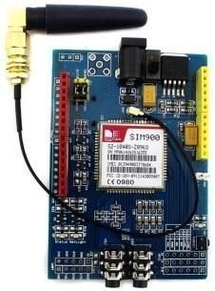SIM 900 GSM/GPRS MODULE:

**Figure 4.12 GSM MODULE**

GSM/GPRS Modem-RS232 is built with Dual Band GSM/GPRS engine- SIM900, works on frequencies 900/ 1800 MHz. The Modem is coming with RS232 interface, which allows you connect PC as well as microcontroller with RS232 Chip (MAX232). The baud rate is configurable from 9600-115200 through AT command. The GSM/GPRS Modem is having internal TCP/IP stack to enable you to connect with internet via GPRS. It is suitable for SMS, Voice as well as DATA transfer application in M2M interface. The onboard Regulated Power supply allows you to connect wide range unregulated power supply. Using this modem, you can make audio calls, SMS, Read SMS, attend the incoming calls and internet through simple AT commands.

FEATURES:

* Dual-Band GSM/GPRS 900/ 1800 MHz.
* RS232 interface for direct communication with computer or MCU kit.
* Configurable baud rate.
* Power controlled using 29302WU IC.
* ESD Compliance.
* Enable with MIC and SPeaker socket.
* With slid in SIM card tray.
* With Stub antenna and SMA connector.
* Input Voltage: 12V DC.

POWER MODES:

**Power down mode:**

* + SIM900A is set power down mode by “AT+CPOWD=0”.
  + There are two methods for the module to enter into low current consumption status.

Minimum Functionality Mode:

* + Minimum functionality mode reduces the functionality of the module to a minimum and thus minimizes the current consumption to the lowest level.
  + If SIM900A has been set to minimum functionality by “AT+CFUN=0”.
  + If SIM900A has been set to full functionality by “AT+CFUN=1”.
  + If SIM900A is set “AT+CFUN=4” to disable both the above functionality.

Sleep mode:

We can control SIM900A module to enter or exit the SLEEP mode in customer applications through DTR signal. When DTR is in high level and there is no on air and hardware interrupt (such as GPIO interrupt or data on serial port), SIM900A will enter SLEEP mode automatically. In this mode, SIM900A can still receive paging or SMS from network but the serial port is not accessible.

Wake up SIM900A from sleep mode:

* Enable DTR pin to wake up SIM900A. If DTR pin is pulled down to a low level.
* This signal will wake up SIM900A from power saving mode. The serial port will be active after DTR changed to low level for about 50ms.
* Receiving a voice or data call from network to wake up SIM900A.
* Receiving a SMS from network to wake up SIM900A.

TABLE 4.6 GSM PIN SPECIFICATIONS

|  |  |  |
| --- | --- | --- |
| **PIN** | **NAME** | **DETAILS** |
| 1 | GND | Power supply ground |
| 2 | TX | transmitter |
| 3 | RX | receiver |
| 4 | Line_r & Line_l | Line input |
| 5 | Spk_p & spk_n | Speaker positive &  negative |
| 6 | Mic_p & mic_n | Mic positive & negative |
| 7 | DTR | Data terminal ready |
| 8 | CTS | Clear to send |
| 9 | RTS | Request to send |

**WORKING:**

Unlike mobile phones, a GSM modem doesn’t have a keypad and display to interact with. It just accepts certain commands through a serial interface and acknowledges for those. These commands are called as AT commands. There is a list of AT commands to instruct the modem to perform its functions. Every command starts with "AT". That’s why they are called as AT commands. AT stands for attention. In our simple project, the program waits for the mobile number to be entered through the keyboard. When a ten-digit mobile number is provided, the program instructs the modem to send the text message using a sequence of AT commands

TESTING YOUR GSM MODEM:

* The GSM modem can be tested by connecting it with a PC. The modem is equipped with a RS232 cable. Just use a Serial to USB converter and connect it with the PC.
* Now you can proceed with sending the commands to the modem using any serial communication program like HyperTerminal, minicom etc. Ensure the serial parameters are configured to 8N1 and the baudrate is set to 9600bps.
* For each command you send the modem acknowledges with a message. Example: Just try sending "AT" to the modem. It sends back a result code "OK" which states that the modem is responding. If it’s not working fine, it sends "ERROR".

AT COMMANDS:

* + Set the SIM900 to text mode: AT+CMGF=1\r.
  + Send SMS to a number: AT+CMGS=PHONE_NUMBER (in international format).
  + Read the first SMS from the inbox: AT+CMGR=1\r.
  + Read the second SMS from the inbox: AT+CMGR=2\r.
  + Read all SMS from the inbox: AT+CMGR=ALL\r.
  + Call to a number: ATDP+PHONE_NUMBER (in international format).
  + Hang up a call: ATH.
  + Receive an incoming call: ATA.

1.6.IR SENSOR

An infrared sensor is an electronic device, that emits in order to sense some aspects of the surroundings. An IR sensor can measure the heat of an object as well as detects the motion. These types of sensors measures only infrared radiation, rather than emitting it that is called as a passive IR sensor. Usually in the infrared spectrum, all the objects radiate some form of thermal radiations. These types of radiations are invisible to our eyes, that can be detected by an infrared sensor. The emitter is simply an IR LED (Light Emitting Diode) and the detector is simply an IR photodiode which is sensitive to IR light of the same wavelength as that emitted by the IR LED. When IR light falls on the photodiode, the resistances and these output voltages, change in proportion to the magnitude of the IR light received.

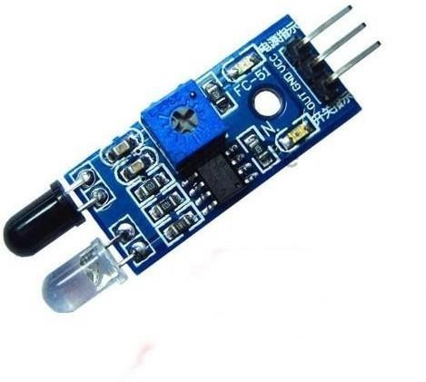

Figure 4.13 IR SENSOR

**WORKING:**

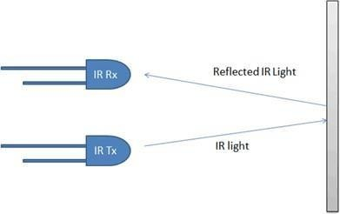

**Figur 4.14 IR sensor working model**

**IR**

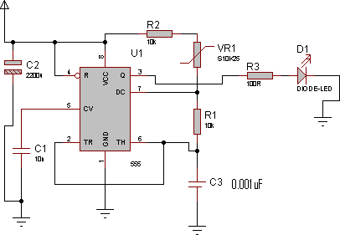

4.15 S 4.15 chematics IR Transmitter

**IR RECEIVER**

This is a very small IR receiver based on the TSOP1738 receiver. This receiver has all the filtering and 38 kHz demodulation built into the unit. Simply point an IR remote at the receiver, a stream of 1s and 0s out of the data from IR transmitter and TSOP capable of receiver only 38khz frequency because in surrounding so many devices transmitting Ir signal at different frequency so we constructed receiver to receive at 38khz frequency only and output of Ir receiver given to microcontroller port three at P3.2.

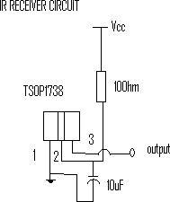

Figure 4.16 IR receiver circuit

* + 1. **LDR SENSOR**

A **Light Dependent Resistor** (aka LDR, photoconductor, or photocell) is a device which has a resistance which varies according to the amount of light falling on its surface.

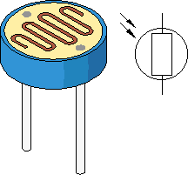

Figure 4.17 LDR SENSOR

A typical light dependent resistor is pictured above together with (on the right-hand side) its circuit diagram symbol. Different LDR's have different specifications, however the **LDR**'s we sell in the REUK Shop are fairly standard and have a resistance in total darkness of 1 MOhm, and a resistance of a couple of kOhm in bright light (*10-20kOhm @ 10 lux, 2-4kOhm @ 100 lux*).

Uses for Light Dependent Resistors

Light dependent resistors are a vital component in any electric circuit which is to be turned on and off automatically according to the level of ambient light - for example, solar powered garden lights.

An LDR can even be used in a simple remote control circuit using the backlight of a mobile phone to turn on a device - call the mobile from anywhere in the world, it lights up the LDR, and lighting (or a garden sprinkler) can be turned on remotely!

Light Dependent Resistor Circuits

There are two basic circuits using **light dependent resistors** - the first is activated by darkness, the second is activated by light. The two circuits are very similar and just require an **LDR**, some standard resistors, a variable resistor (aka potentiometer), and any small signal transistor.

Using an LDR in the Real World

The circuits shown above are not practically useful. In a real-world circuit, the LED (and resistor) between the positive voltage input (Vin) and the collector (C) of the

transistor would be replaced with the device to be powered.

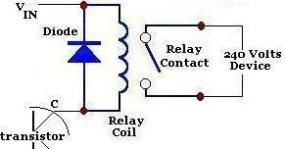

Figure 4.18 circuit diagram of LDR

Typically a relay is used - particularly when the low voltage light detecting circuit is used to switch on (or off) a 240V mains powered device. A diagram of that part of the circuit is shown above. When darkness falls (if the LDR circuit is configured that way around), the relay is triggered and the 240V device - for example a security light - switches on.

4.3.SOFTWARE ENVIRONMENT

**4.3.1ARDUINO SOFTWARE (IDE):**

The Arduino Integrated Development Environment - or Arduino Software (IDE) - contains a text editor for writing code, a message area, a text console, a toolbar with buttons for common functions and a series of menus. It connects to the Arduino and Genuine hardware to upload programs and communicate with them.

WRITING SKETCHES:

Programs written using Arduino Software (IDE) are called sketches. These sketches are written in the text editor and are saved with the file extension .ino. The editor has features for cutting/pasting and for searching/replacing text. The message area gives feedback while saving and exporting and also displays errors. The console displays text output by the Arduino Software (IDE), including complete error messages and other information. The bottom right hand corner of the window displays the configured board and serial port. The toolbar buttons allow you to verify and upload programs, create, open, and save sketches, and open the serial monitor.

NB: Versions of the Arduino Software (IDE) prior to 1.0 saved sketches with the extension .pde. It is possible to open these files with version 1.0, you will be prompted to save the sketch with the .ino extension on save.

|  |  |
| --- | --- |
|  | ***Verify***  Checks your code for errors compiling it. |
|  | ***Upload***  Compiles your code and uploads it to the configured board. See [uploading](https://www.arduino.cc/en/guide/environment%23uploading) below for details.  Note: If you are using an external programmer with your board, you can hold down the "shift" key on your computer when using this icon. The text will change to "Upload using Programmer" |
|  | ***New***  Creates a new sketch. |
|  | ***Open***  Presents a menu of all the sketches in your sketchbook. Clicking one will open it within the current window overwriting its content.  Note: due to a bug in Java, this menu doesn't scroll; if you need to open a sketch late in the list, use the **File | Sketchbook** menu instead. |
|  | ***Save***  Saves your sketch. |
|  | ***Serial Monitor***  Opens the [serial monitor](https://www.arduino.cc/en/guide/environment%23serialmonitor). |

Figure 4.19 classification of tools in Arduino IDE

Additional commands are found within the five menus: **File**, **Edit**, **Sketch**, **Tools**, and help. The menus are context sensitive, which means only those items relevant to the work currently being carried out are available.

SKETCHBOOK:

The Arduino Software (IDE) uses the concept of a sketchbook: a standard place to store your programs (or sketches). The sketches in your sketchbook can be opened from the **File > Sketchbook** menu or from the **Open** button on the toolbar. The first time you run the Arduino software, it will automatically create a directory for your sketchbook. You can view or change the location of the sketchbook location from with the **Preferences** dialog.

Beginning with version 1.0, files are saved with a .ino file extension. Previous versions use the .pde extension. You may still open .pde named files in version 1.0 and later, the software will automatically rename the extension to .ino.

**TABS, MULTIPLE FILES, AND COMPILATION:**

Allows you to manage sketches with more than one file (each of which appears in its own tab). These can be normal Arduino code files (no visible extension), C files (.c extension), C++ files (.cpp), or header files (.h).

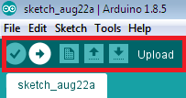UPLOADING:

Before uploading your sketch, you need to select the correct items from the **Tools > Board** and **Tools > Port** menus. The boards are described below. On the Mac, the serial port is probably something like **/dev/tty.usbmodem241** (for an Uno or Mega2560 or Leonardo) or **/dev/tty.usbserial-1B1** (for a Duemilanove or earlier USB board), or **/dev/**tty.USA19QW1b1P1**.1** (for a serial board connected with a Keyspan USB-to-Serial adapter). On Windows, it's probably COM1 or COM2 (for a serial board) or COM4, COM5, COM7, or higher (for a USB board) - to find out, you look for USB serial device in the ports section of the Windows Device Manager. On Linux, it should be **/dev/ttyACMx** , **/dev/ttyUSBx** or similar. Once you've selected the correct serial port and board, press the upload button in the toolbar or select the **Upload** item from the **Sketch** menu. Current Arduino boards will reset automatically and begin the upload. With older boards (pre-Diecimila) that lack auto-reset, you'll need to press the reset button on the board just before starting the upload. On most boards, you'll see the RX and TX LEDs blink as the sketch is uploaded. The Arduino Software (IDE) will display a message when the upload is complete or show an error.

When you upload a sketch, you're using the Arduino **bootloader**, a small program that has been loaded on to the microcontroller on your board. It allows you to upload code without using any additional hardware. The bootloader is active for a few seconds when the board resets; then it starts whichever sketch was most recently uploaded to the microcontroller. The boot loader will blink the on-board (pin 13) LED when it starts (i.e. when the board resets).

LIBRARIES:

Libraries provide extra functionality for use in sketches, e.g. working with hardware or manipulating data. To use a library in a sketch, select it from the **Sketch > Import Library** menu. This will insert one or more **#include** statements at the top of the sketch and compile the library with your sketch. Because libraries are uploaded to the board with your sketch, they increase the amount of space it takes up. If a sketch no longer needs a library, simply delete its **#include** statements from the top of your code.

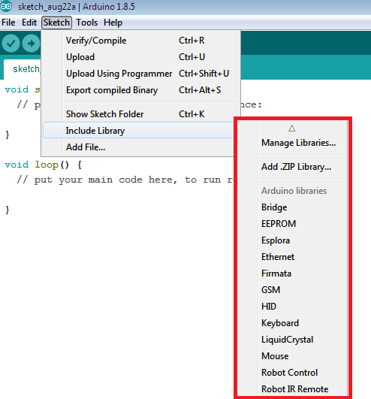

FIGURE 4.20 LIBRARIES OF ARDUINO IDE

There is a list of libraries in the reference. Some libraries are included with the Arduino software. Others can be downloaded from a variety of sources or through the Library Manager. Starting with version 1.0.5 of the IDE, you do can import a library from a zip file and use it in an open sketch. See these instructions for installing a third- party library.

THIRD-PARTY HARDWARE:

Support for third-party hardware can be added to the **hardware** directory of your sketchbook directory. Platforms installed there may include board definitions (which appear in the board menu), core libraries, bootloaders, and programmer definitions. To install, create the **hardware** directory, then unzip the third-party platform into its own sub-directory. (Don't use "arduino" as the sub-directory name or you'll override the built-in Arduino platform.) To uninstall, simply delete its directory.

For details on creating packages for third-party hardware, see the Arduino IDE 1.5 3rd party Hardware specification.

SERIAL MONITOR:

This displays serial sent from the Arduino or Genuino board over USB or serial connector. To send data to the board, enter text and click on the "send" button or press enter. Choose the baud rate from the drop-down menu that matches the rate passed to **Serial.begin** in your sketch. Note that on Windows, Mac or Linux the board will reset (it will rerun your sketch) when you connect with the serial monitor. Please note that the Serial Monitor does not process control characters; if your sketch needs a complete management of the serial communication with control characters, you can use an external terminal program and connect it to the COM port assigned to your Arduino board.

You can also talk to the board from Processing, Flash, MaxMSP, etc (see the interfacing page for details).

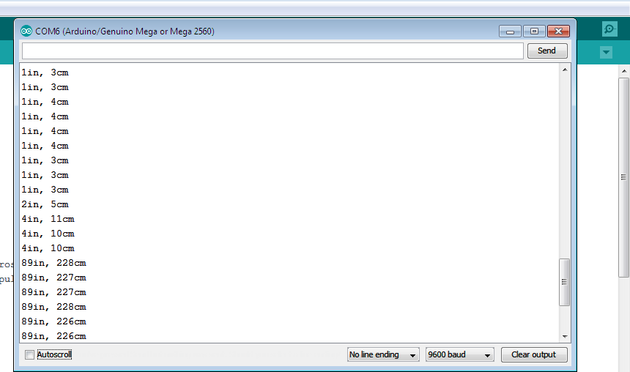

Figure 4.21 Serial monitor

**PREFERENCES:**

Some preferences can be set in the preferences dialog (found under the **Arduino** menu on the Mac, or **File** on Windows and Linux). The rest can be found in the preferences file, whose location is shown in the preference dialog.

LANGUAGE SUPPORT:

Since version 1.0.1 , the Arduino Software (IDE) has been translated into 30+ different languages. By default, the IDE loads in the language selected by your operating system. (Note: on Windows and possibly Linux, this is determined by the locale setting which controls currency and date formats, not by the language the operating system is displayed in.)

If you would like to change the language manually, start the Arduino Software (IDE) and open the **Preferences** window. Next to the **Editor Language** there is a dropdown menu of currently supported languages. Select your preferred language from

the menu, and restart the software to use the selected language. If your operating system language is not supported, the Arduino Software (IDE) will default to English.

You can return the software to its default setting of selecting its language based on your operating system by selecting **System Default** from the **Editor Language** drop-down. This setting will take effect when you restart the Arduino Software (IDE). Similarly, after changing your operating system's settings, you must restart the Arduino Software (IDE) to update it to the new default language.

4.4 EMBEDDED C

Embedded C is most popular programming language in software field for developing electronic gadgets. Each processor used in electronic system is associated with embedded software.

Embedded C programming plays a key role in performing specific function by the processor. In day-to-day life we used many electronic devices such as mobile phone, washing machine, digital camera, etc. These all device working is based on microcontroller that are programmed by embedded C.

Let's see the block diagram representation of embedded system programming:

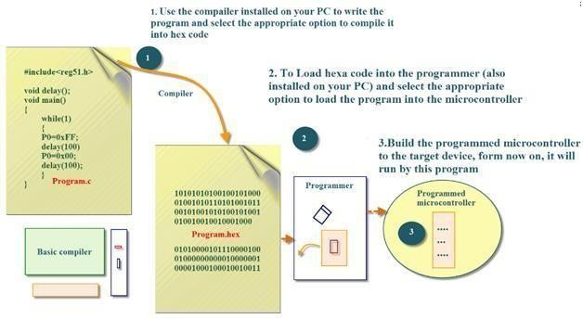

Figure 4.22 The Embedded C code block diagram to glow a bulb.

In embedded system programming C code is preferred over other language.

Due to the following reasons:

* Easy to understand
* High Reliability
* Portability
* Scalability

EMBEDDED SYSTEM PROGRAMMING:

**Basic Declaration**

Let's see the block diagram of Embedded C Programming development:

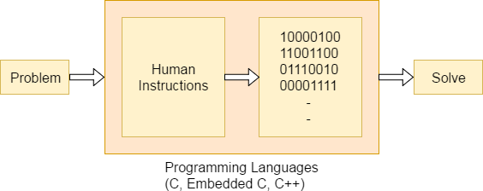

Figure 4.23 Embedded C programming language

Function is a collection of statements that is used for performing a specific task and a collection of one or more functions is called a programming language. Every language is consisting of basic elements and grammatical rules. The C language programming is designed for function with variables, character set, data types, keywords, expression and so on are used for writing a C program.

The extension in C language is known as embedded C programming language. As compared to above the embedded programming in C is also have some additional features like data types, keywords and header file etc is represented by #include**<microcontroller** name.h**>**.

BASIC EMBEDDED C PROGRAMMING STEPS:

Let's see the block diagram representation of Embedded C Programming

Steps:

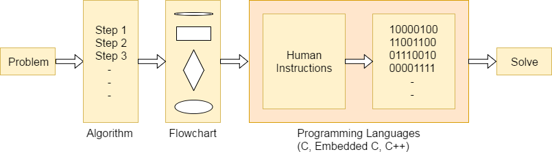

The microcontroller programming is different for each type of operating system. Even though there are many operating system are exist such as Windows, Linux, RTOS, etc but RTOS has several advantage for embedded system development.

EMBEDDED SYSTEMS:

Embedded System is a system composed of hardware, application software and real time operating system. It can be small independent system or large combinational system.

Our Embedded System tutorial includes all topics of Embedded System such as characteristics, designing, processors, microcontrollers, tools, addressing modes, assembly language, interrupts, embedded c programming, led blinking, serial communication, lcd programming, keyboard programming, project implementation etc.

SYSTEM:

**System** is a way of working, organizing or performing one or many tasks according to a fixed set of rules, program or plan.

It is an arrangement in which all the unit combined to perform a work together by following certain set of rules in real time computation. It can also be defined as a way of working, organizing or doing one or many tasks according to a fixed plan.

An **Embedded System** is a system that has software embedded into computer-hardware, which makes a system dedicated for a variety of application or specific part of an application or product or part of a larger system.

An embedded system can be a small independent system or a large combinational system. It is a microcontroller-based control system used to perform a

specific task of operation.

An embedded system is a combination of three major components:

* **Hardware:** Hardware is physically used component that is physically connected with an embedded system. It comprises of microcontroller based integrated circuit, power supply, LCD display etc.
* **Application software:** Application software allows the user to perform varieties of application to be run on an embedded system by changing the code installed in an embedded system.
* **Real Time Operating system (RTOS):** RTOS supervises the way an embedded system work. It act as an interface between hardware and application software which supervises the application software and provide mechanism to let the processor run on the basis of scheduling for controlling the effect of latencies.

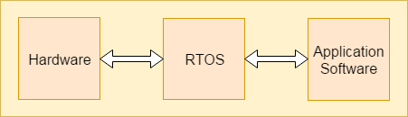

Figure 4.24 RTOS working module

**CHARACTERISTICS OF EMBEDDED SYSTEM:**

* An embedded system is software embedded into computer hardware that makes a system dedicated to be used for variety of application.
* Embedded system generally used for do specific task that provide real-time output on the basis of various characteristics of an embedded system.
* Embedded system may contain a smaller part within a larger device that used for serving the more specific application to perform variety of task using hardware-software intermixing configuration.
* It provides high reliability and real-time computation ability.

Advantages:

* Same hardware can be used in variety of application.
* Lesser power requirement
* Lower operational cost of system
* Provide high performance and efficiency

Disadvantages:

* Developing a system required more time. Due to functional complexity.
* Skilled engineers required because one mistake may result in destroying of complete project.

BASIC STRUCTURE OF AN EMBEDDED SYSTEM:

Let's see the block diagram shows the basic structure of an embedded

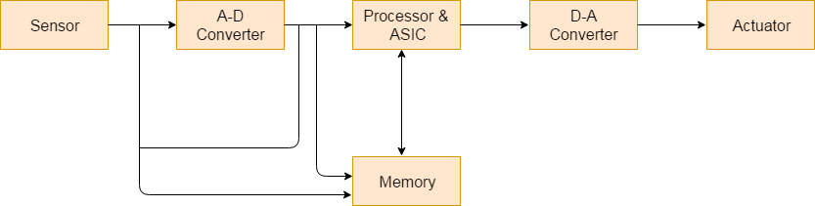system.

FIGURE 4.25 Basic Structure Of Embedded System

* **Sensor**: Sensor used for sensing the change in environment condition and it generate the electric signal on the basis of change in environment condition. Therefore it is also called as transducers for providing electric input signal on the basis of change in environment condition.
* **A-D Converter**: An analog-to-digital converter is a device that converts analog electric input signal into its equivalent digital signal for further processing in an embedded system.
* **Processor & ASICs**: Processor used for processing the signal and data to execute desired set of instructions with high-speed of operation.Application specific integrated circuit (ASIC) is an integrated circuit designed to perform task specific operation inside an embedded system.
* **D-A Converter**: A digital-to-analog converter is a device that converts digital electric input signal into its equivalent analog signal for further processing in an embedded system.
* **Actuators**: Actuators is a comparator used for comparing the analog input signal level to desired output signal level for providing the error free output from the system.

DESIGN STEPS REQUIRED FOR THE DEVELOPMENT OF EMBEDDED SYSTEM:

Designing steps required for embedded system are different from the design process of another electronic system.

Let's see a flow chart represent the design steps required in the development of an embedded system:

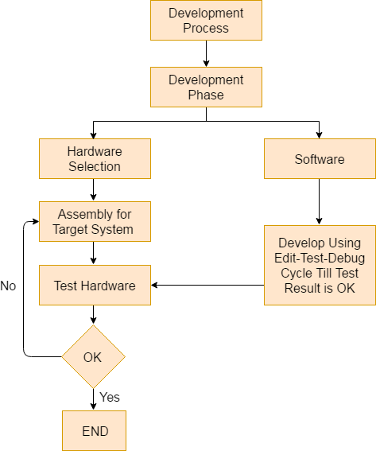

Figure 4.26 Flowchart For development of the system

**EMBEDDED SYSTEM TOOLS AND PERIPHERALS:**

**Compilers and Assemblers: Compiler:**

Compiler is used for converting the source code from a high-level programming language to a low-level programming language. It converts the code written in high level programming language into assembly or machine code. The main reason for conversion is to develop an executable program.

Let's see the operations performed by compiler are:

* Code generation
* Code optimization
* Parsing
* Syntax direct translation
* Preprocessing

Cross-Compiler:

If a program compiled is run on a computer having different operating system and hardware configuration than the computer system on which a compiler compiled the program, that compiler is known as cross-compiler.

Decompiler:

A tool used for translating a program from a low-level language to high- level language is called a decompiler. It is used for conversion of assembly or machine code to high-level programming language.

Assembler:

Assembler is embedded system tool used for translating a computer instruction written in assembly language into a pattern of bits which is used by the computer processor for performing its basic operations. Assembler creates an object code by translating assembly language instruction into set of mnemonics for representing each low-level machine operation.

DEBUGGING TOOLS IN AN EMBEDDED SYSTEM:

Debugging is a tool used for reducing the number of error or bugs inside a computer program or an assembled electronic hardware.

Debugging of a compact subsystem is difficult because a small change in one subsystem can create bugs in another system. The debugging used inside embedded system differs in terms of their development time and debugging features.

Let's see the different debugging tools used in embedded system are: Simulators:

Simulator is a tool used for simulation of an embedded system. Code tested for microcontroller unit by simulating code on the host computer. Simulator is used for model the behavior of the complete microcontroller in software.

Functions of simulators:

Let's see the functions performed by simulator are:

* It defines the processing or processor device family with various version of target system.
* It monitors the detailed information of a source code and symbolic arguments as the execution goes for each single step of operation.
* It simulates the ports of target system for each single step of execution.
* It provides the working status of RAM.
* It monitors the response of system and determines the throughput.
* It provides the complete meaning of the present command.
* It monitors the detailed information of the simulator commands entered from the keyboard or selected from the menu.
* It facilitates synchronization of internal peripherals and delays.

MICROCONTROLLER STARTER KIT:

For developing an embedded system based project a complete microcontroller starter kit is required. The major advantage of this kit over simulator is that they work in real-time operating condition. Therefore it allows the easy input/output functional verification. Consider a microcontroller starter kit consists of:-

* Hardware Printed Circuit Board (PCB)
* In-System Programmer (ISP)
* Some embedded system tools like compiler, assembler, linker, etc
* Sometimes, there is a requirement of an Integrated Development Environment (IDE)

The above component available in microcontroller starter kit is completely enough and the cheapest option available for developing simple microcontroller projects.

Emulators:

An emulator is a software program or a hardware kit which emulates the

functions of one computer system into another computer system. Emulators have an ability to support closer connection to an authenticity of the digital object.

It can also be defined as the ability of a computer program in electronic device to emulate another program or device. It focusing on recreating the original computer environment and helps a user to work on any type of application or operating system.

PERIPHERAL DEVICES IN EMBEDDED SYSTEMS:

Communication of an embedded system with an outside environment is done by using different peripheral devices as a combination with microcontroller.

Let's see the different peripheral devices in embedded system are:-

* Universal Serial Bus (USB)
* Networks like Ethernet, Local Area Network(LAN) etc
* Multi Media Cards (SD Cards, Flash memory, etc)
* Serial Communication Interface (SCI) like RS-232, RS-485, RS-422, etc
* Synchronous Serial Communication Interface like SPI, SSC and ESSI
* Digital to Analog/ Analog to Digital (DAC/ADC)
* General Purpose Input/Output (GPIO)
* Debugging like In System Programming (ISP), In Circuit Serial Programming (ICSP), BDM Port, etc

**CHAPTER 5**

**SYSTEM**

**IMPLEMENTATION**

SYSTEM IMPLEMENTATION

A process of putting a planned system into action. The stage of systems development in which hardware and software are acquired, developed and installed, the system is tested and documented, people are trained to operate and use the system, and an organization converts to the use of a newly developed system.

**5.1 Overview:**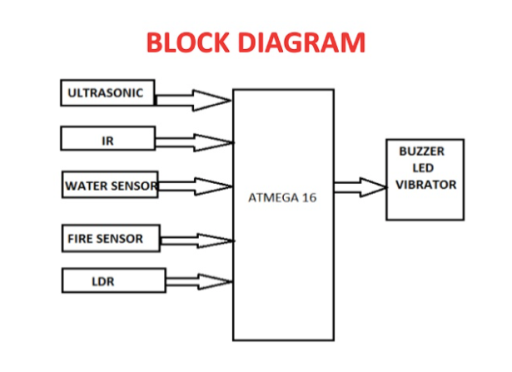

* In our system, we have ARDUINO MEGA microcontroller which acts as brain of our system, hence entire system program is stored in it.
* Here we have used ultrasonic sensor and infrared sensor to know about obstacle distance and detection.
* LDR sensor and fire sensor used for to know about light intensity and fire detection.
* If fire detected sound will turn on to alert the blind person.
* SOS button used for emergency time message will send to the concern person.

**MODULE DESCRIPTION:**

Project is designed in four modules where each module is responsible for different aspects.

* Arduino board.
* Fire sensor
* Vibration sensor
* Ultrasonic sensor
* LDR sensor
* IR sensor.

**Arduino Board:**

* Arduino board acts as the brain of the system.
* It controls every other sensors.
* Since it acts as a brain, any damage happens to it affect the whole system.

**FIRE SENSOR:**

* Fire sensors detect the fire or substances with high temperature
* Fire sensors allow the user to identify and alerts the user by giving a buzzer sound.

**IR SENSOR:**

* IR sensors uses detects nearby obstacles.
* IR sensor is a sensitive sensor
* It emits IR radiations

**ULTRASONIC SENSOR:**

* Ultrasonic sensor detects the distance of the object.
* In which it emits ultrasonic signals to detect the obstacles.
* It is cheap when compared to other sensors.

**VIBERATION SENSOR:**

* Vibration sensor works by piezoelectric effect.
* It analyses the difference in acceleration , sudden change of force .

**CHAPTER 6**

**SYSTEM TESTING**

**TEST CASES:**

Testing is a process, which reveals errors in the program. It is the major quality measure employed during software development. During software development. During testing, the program is executed with a set of test cases and the output of the program for the test cases is evaluated to determine if the program is performing as it is expected to perform.

|  |  |  |  |  |
| --- | --- | --- | --- | --- |
| Test case no. | Action | Expected output | Actual output | Result |
| 1 | IR sensor connected to Arduino borad | To Detect nearby obstacles. | Detect nearby obstacles. | Pass |
| 2 | Ultrasonic sensor connected to the Board | To detect far away obstacles. | Detects far away obstacles. | Pass |
| 3 | Fire sensor connected to the board | To detect fire /Flames/objects with high temperature. | It detects the fire and High intense heat radiation. | Pass |
| 4 | Viberation sensor connected | To monitor the user If the user fells down it should detect the accident | The vibration sensor detect intense vibration. | Pass |

|  |  |  |  |  |
| --- | --- | --- | --- | --- |
| 5 | GSM SYSTEM | To Send message to the respective person. | It sends the message to the respective person. | Pass |
| 6 | Emergency button | To Sends the message to the respective number | The button works and sends message to the respective number. | Pass |
| 7 | LDR sensor connected to the Board | To alert he user when he enters dark places . | The kit alerts the user when he enter dark places | Pass |

**CHAPTER 7**

**CONCLUSION**

* 1. CONCLUSION AND FUTURE ENHANCEMENT

Blind people face lot of difficulties while travelling from one place to another. With the intention to help the blind, their difficulties, the smart blind stick is proposed. The system consists of an LDR sensor to detect day and night and ultrasonic sensor to obstacle detection. The proposed system takes the blind person to reach the destination without any struggle in their path. After testing, the system proposed in this paper helps users walk in a relatively safe environment reliably, such as indoors, parks, and schools. The system not only make them more free, but also liberate their minds and throw away many worries and doubts. However, in some specific open environment, such as on the road, the blind still need someone accompany them if they have to take a long trip. The effect of the system will reduced the dependency of Others.

* 1. FUTURE SCOPE

The project has a very good scope in future as well as in present. The project can be implemented with the different sensor to guide the visually challenged people in the world. The main theme of this project is to help the blind people and make them to interact with the physical world. In future this project can be developed by adding GPS and GSM module. The module were used to track the location of the blind people. The emergency button were placed to help them if they are in any danger or they need any help. Then the device were placed in their clothes or hat to make the device more portable and easy to used by the blind people.

**APPENDICES**

**A) CODING** #define buzzer 3 #define ir 4 #define fire 5 #define ldr 6 #define button 7 #define vib 2 #define trig 8 #define echo 9

unsigned int d,obstacle,fire_state,light_intensity,sw; void VIB();

int ultra();

void send_sms(String phno, String data); bool vib_flag;

void setup() {

// put your setup code here, to run once:

Serial.begin(9600);

pinMode(ir, INPUT); pinMode(fire, INPUT); pinMode(ldr, INPUT); pinMode(button, INPUT); pinMode(vib, INPUT); pinMode(echo, INPUT);

pinMode(trig, OUTPUT); pinMode(buzzer, OUTPUT); attachInterrupt(digitalPinToInterrupt(vib), VIB, FALLING);

}

void loop() {

// put your main code here, to run repeatedly: digitalWrite(buzzer,LOW);

d = ultra();

obstacle = digitalRead(ir); fire_state = digitalRead(fire); light_intensity = digitalRead(ldr); sw = digitalRead(button);

if (d < 5)

{

digitalWrite(buzzer,HIGH);delay(1000);

}

if (obstacle == LOW)

{

digitalWrite(buzzer,HIGH); Serial.println("OBSTACLE DETECTED");delay(1000);

}

if (fire_state == LOW)

{

digitalWrite(buzzer,HIGH); send_sms("9566987610","FIRE DETECTED");

}

if (sw == HIGH)

{

send_sms("9566987610","I AM AT EMERGENCY SITUATION");

}

if (light_intensity == LOW)

{

Serial.println("DAY TIME");

}

if (vib_flag == 1)

{

send_sms("9566987610","BLIND PERSON FELL DOWN");

vib_flag=0;

}

}

void VIB()

{

if (digitalRead(vib) == 0)

{

vib_flag = 1;

}

}

int ultra()

{

digitalWrite(trig, LOW); delay(10); digitalWrite(trig, HIGH);

delay(10); digitalWrite(trig, LOW);

int duration = pulseIn(echo, HIGH); int distance = (duration * 0.034) / 2; return distance;

}

void send_sms(String phno, String data)

{

Serial.println("AT"); delay(100);

Serial.println("AT+CMGF=1"); //msg mode delay(100);

Serial.println("AT+CMGS=\"+91" + phno + "\"\r"); delay(100);

Serial.println(data); delay(100); Serial.println((char)26); delay(1200);

}

**B)** **SCREENSHOTS**

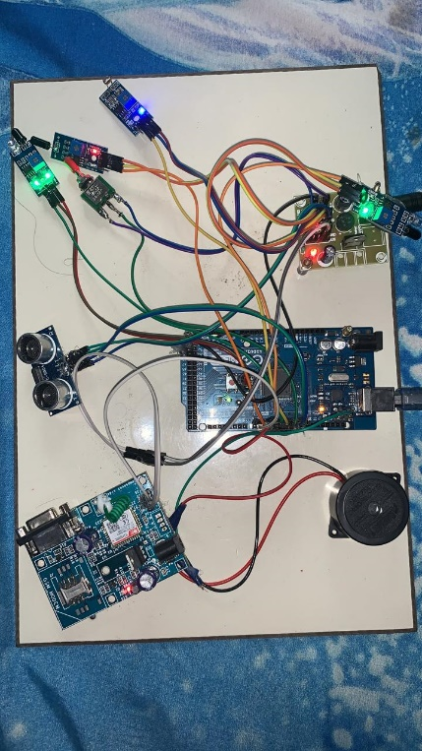

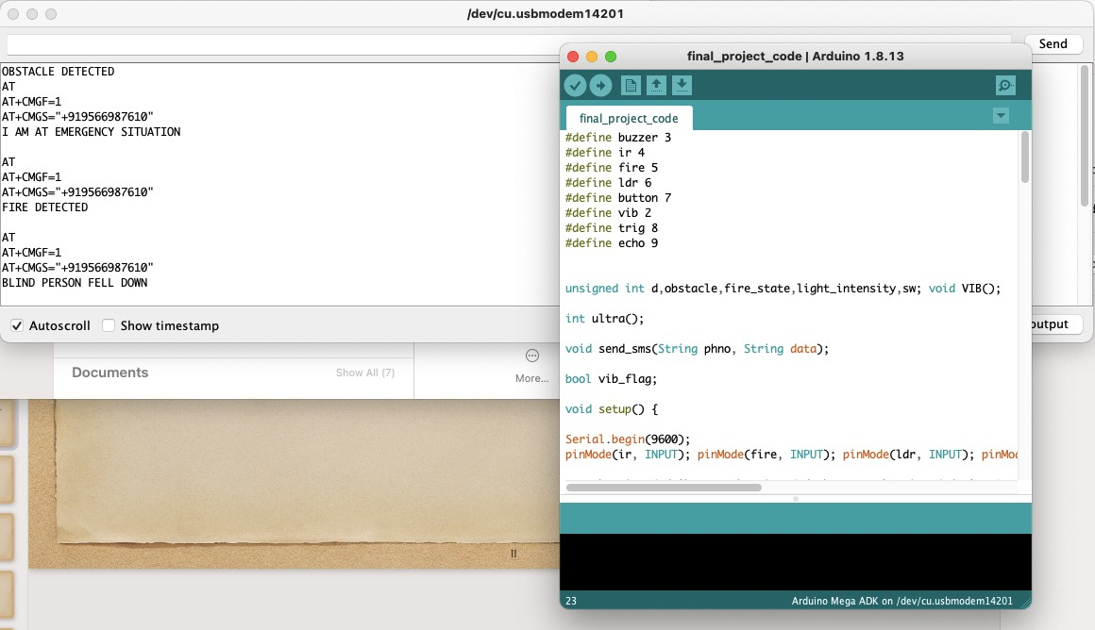

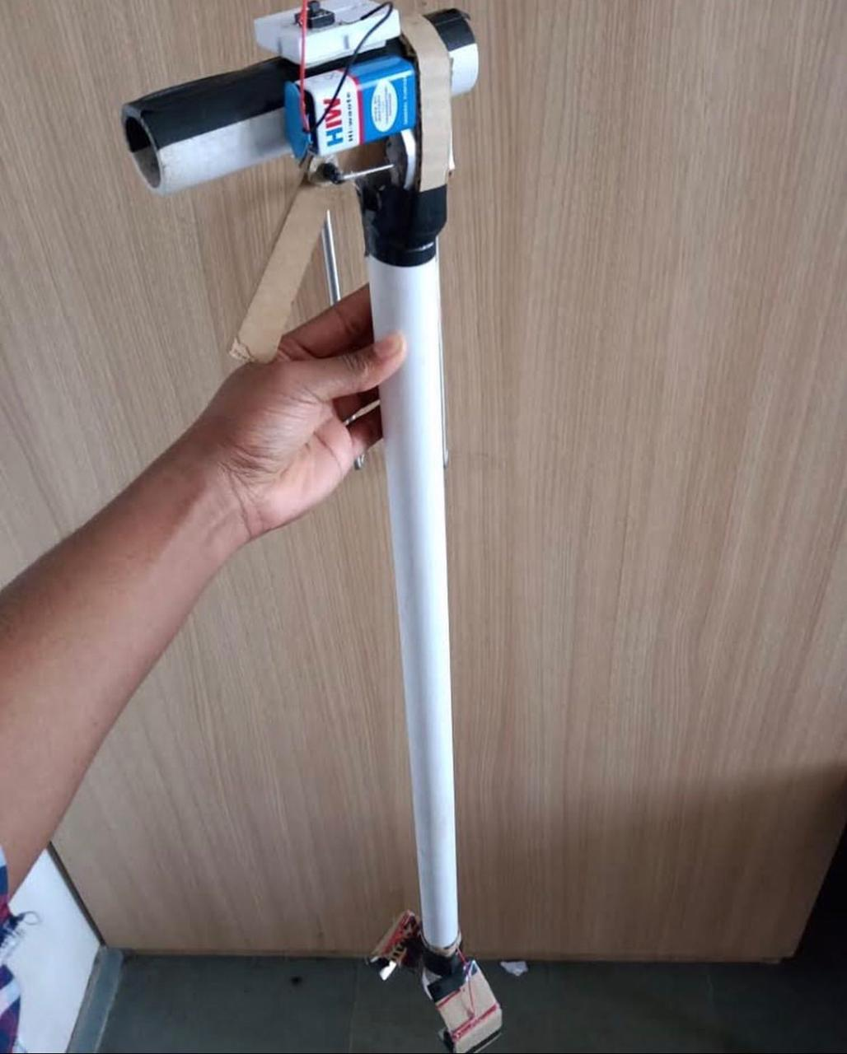

REFERENCES:

[1]Yeong-Hwa Chang, Nilima Sahoo and Hung-Wei Lin. ―An Intelligent Walking Stick for the Visually Challenged People. In IEEE International Conference on Applied System Innovation, 2018.

[2]Nitish Ojha1, Pravin Kumar Pradhan, Prof. M.V.Patil. ―Obstacle Sensing Walking Stick for Visually Impaired. In International Research Journal of Engineering and

[3] Yi-Qing Liu, Zhi-Kai Gao , Zhang-Jian Shao and Gu-Yang Liu. ―Intelligent ultrasonic detection of walking sticks for the blind. In International Conference – 9th Edition Electronics, Computers and Artificial Intelligence, July 2017.

[4] Akhilesh Krishnan, Deepakraj G, Nishanth N, Dr.K.M.Anandkumar. ―Autonomous Walking Stick For The Blind Using Echolocation And Image Processing. In IEEE International Conference, 2016.

[5] Sharada Murali, Shrivatsan R, Sreenivas V, Srihaarika Vijjappu , Joseph Gladwin S, Rajavel R. ―Smart Walking Cane for the Visually Challenged. In IEEE International Conference, 2016.

[6] Giva Andriana Mutiara, Gita Indah Hapsari, Ramanta Rijalul. ―Smart Guide Extension for Blind Cane. In Fourth International Conference on Information and Communication Technologies (ICoICT), 2016.

[7] M.F. Saaid, A. M. Mohammad, M. S. A. Megat Ali. ―Smart Cane with Range Notification for Blind People. IEEE International Conference on Automatic Control and Intelligent Systems (I2CACIS), October 2016.

[8] Ayat A. Nada, Mahmoud A. Fakhr, Ahmed F. Seddik. ―Assistive Infrared Sensor Based Smart Stick for Blind People. In Science and Information Conference, July 2015